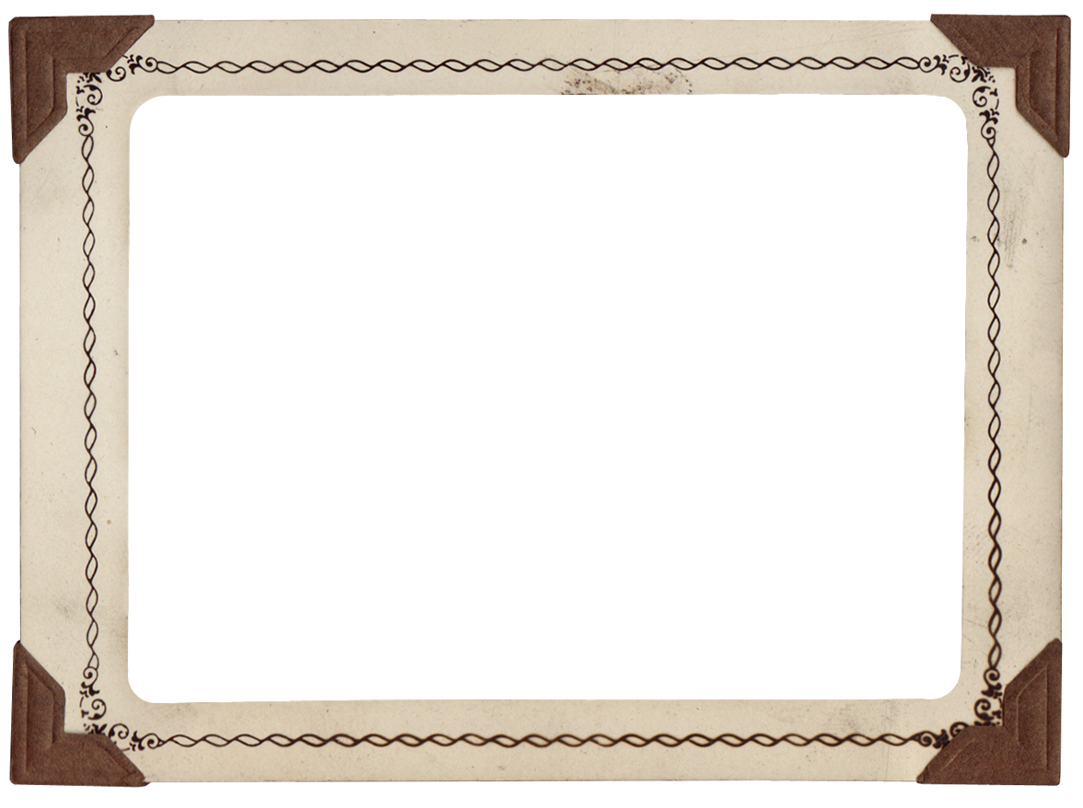

Insert child’s photo

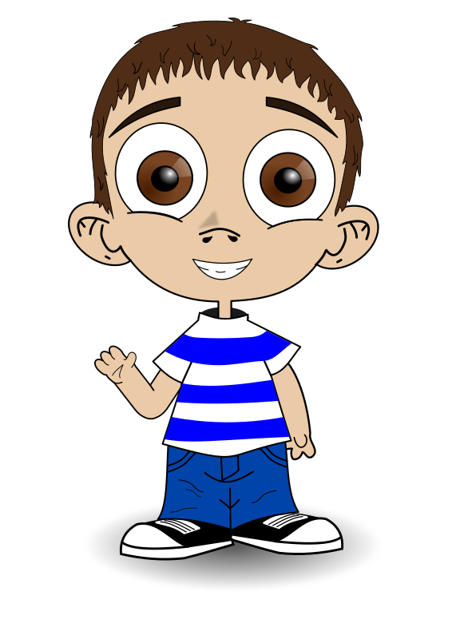

By

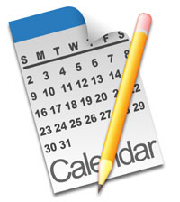

**MY YEAR OF ADVENTURES**

My name is Joseph

And these are some of my adventures in 2016 and 2017

As told to My Mom and Dad

[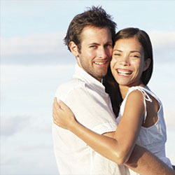](http://www.google.com/url?sa=i&rct=j&q=&esrc=s&source=images&cd=&cad=rja&uact=8&ved=0ahUKEwjRhsv06sjNAhWDRiYKHU4xBZIQjRwIBw&url=http%3A%2F%2Fwww.doctorwellgood.com%2Flustdiseases%2Ftrichomonas.html&psig=AFQjCNHXhKsZQGTBgujXS0AGWL6kgKTxEA&ust=1467138463088911)

Change name and insert picture of giver of book

Copyright © 2016 Xanadu Inc. See Instructions on how to tailor this book to your child and permitted uses and copying.

**I went to the zoo with guess who?**

**My sister that’s who.**

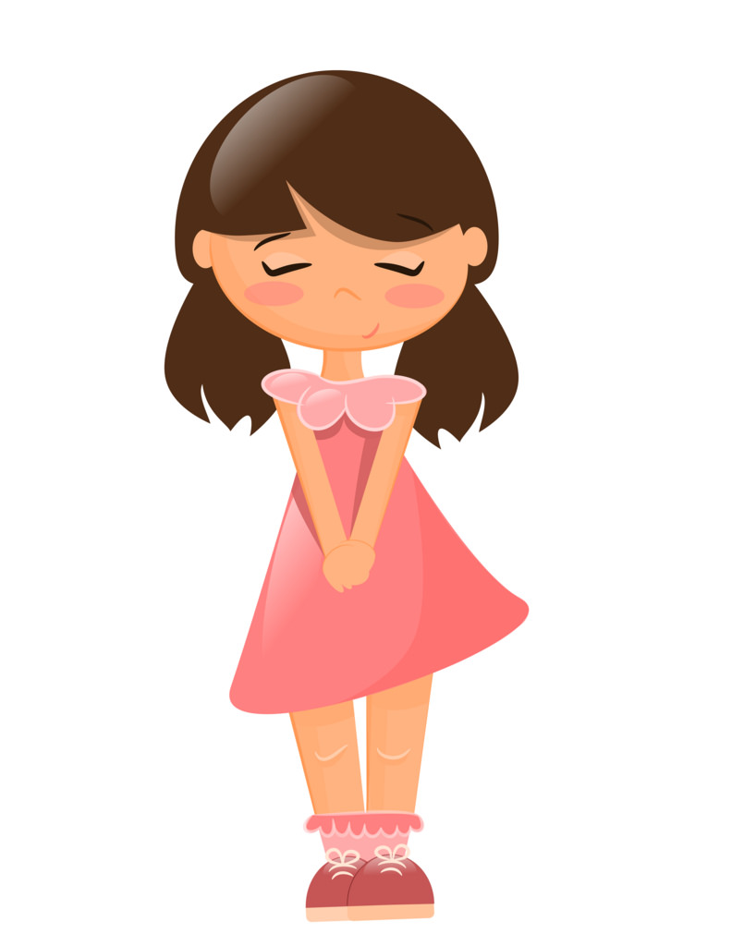

Insert sibling photo or if none add picture and name of person/persons child went with.

**I saw a giraffe.**

**He makes me laugh.**

**You see on December 10**

**It’s her birthday.**

[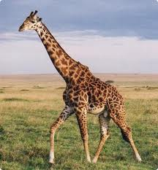](http://www.google.com/url?sa=i&rct=j&q=&esrc=s&source=images&cd=&cad=rja&uact=8&ved=&url=http://dicasecuriosidadesdetudo.blogspot.com/&psig=AFQjCNEu5UKOOf-4WUGstFGAu3Hqigo7kA&ust=1463759210413347)

**His legs are so long they hardly belong.**

**It will be a ton of fun!**

**Hooray!!**

**There was a bear with lots of hair and up in a tree**

**I could see a monkey**

[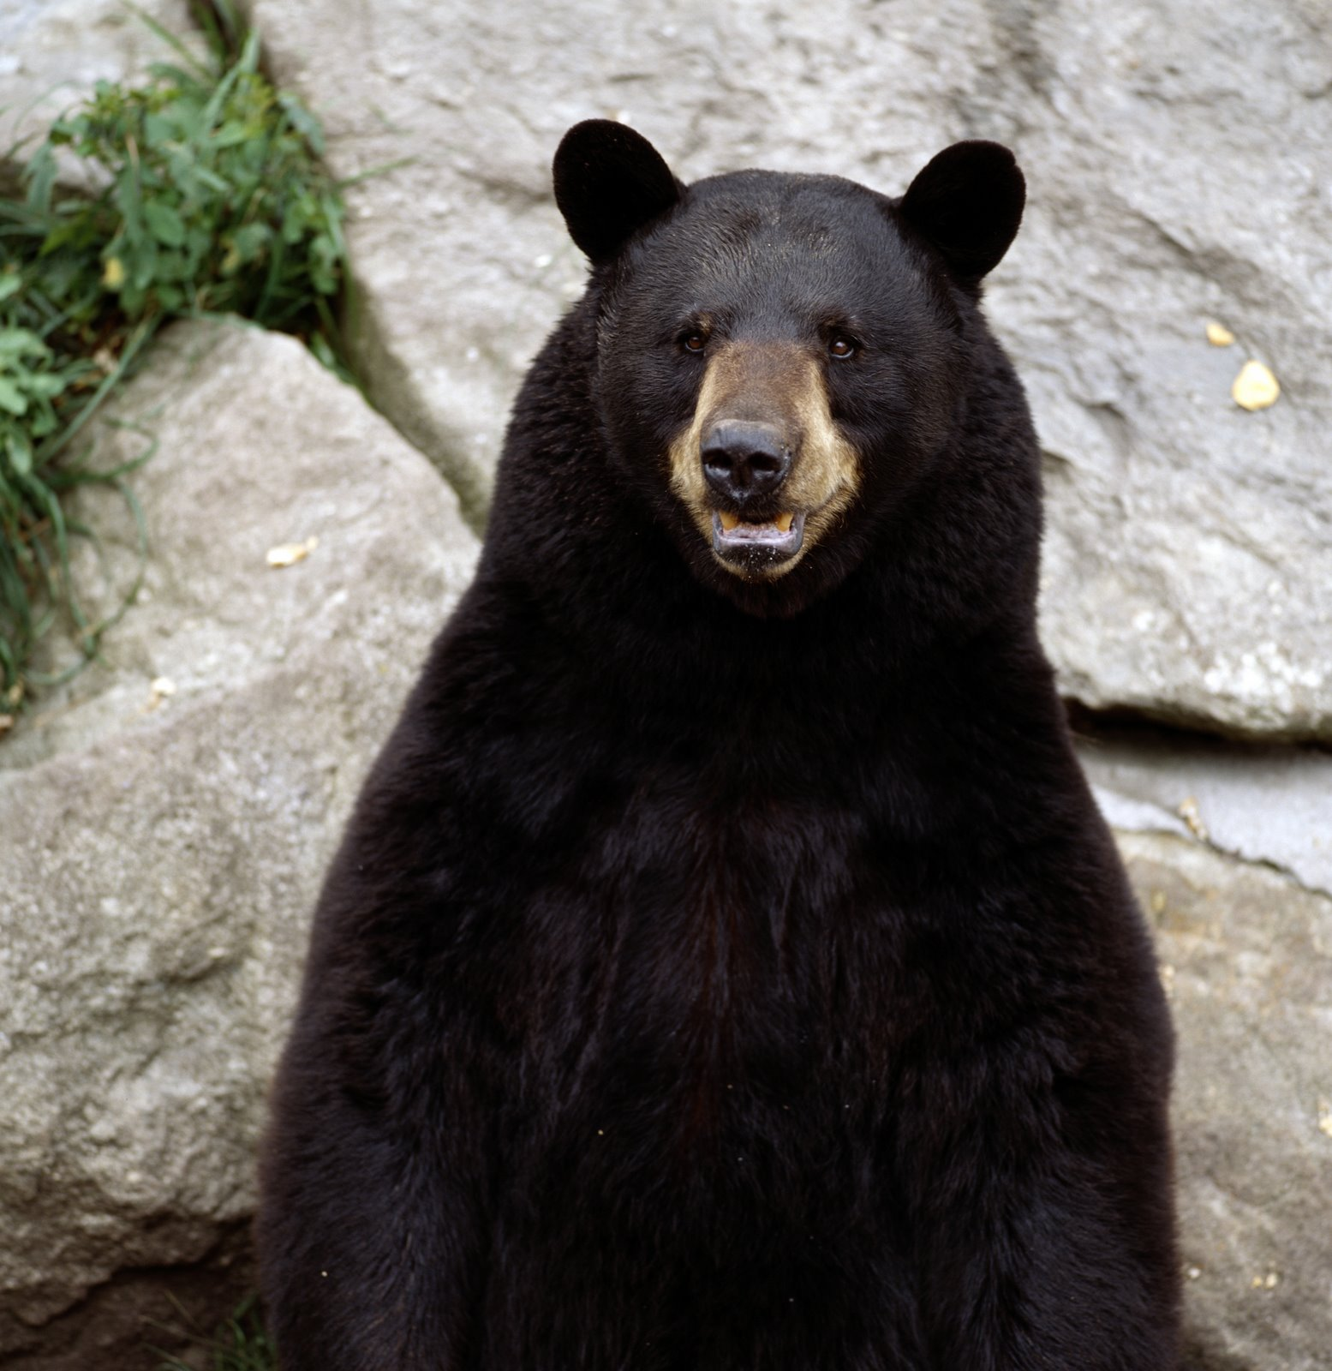](http://www.google.com/url?sa=i&rct=j&q=&esrc=s&source=images&cd=&cad=rja&uact=8&ved=0ahUKEwiK1Ljsw4nNAhVDIFIKHRFQDiIQjRwIBw&url=http://dreamatico.com/bear.html&psig=AFQjCNHLiFyun3eMN-1tGYFPPzlvWjv0gQ&ust=1464963326961592)

[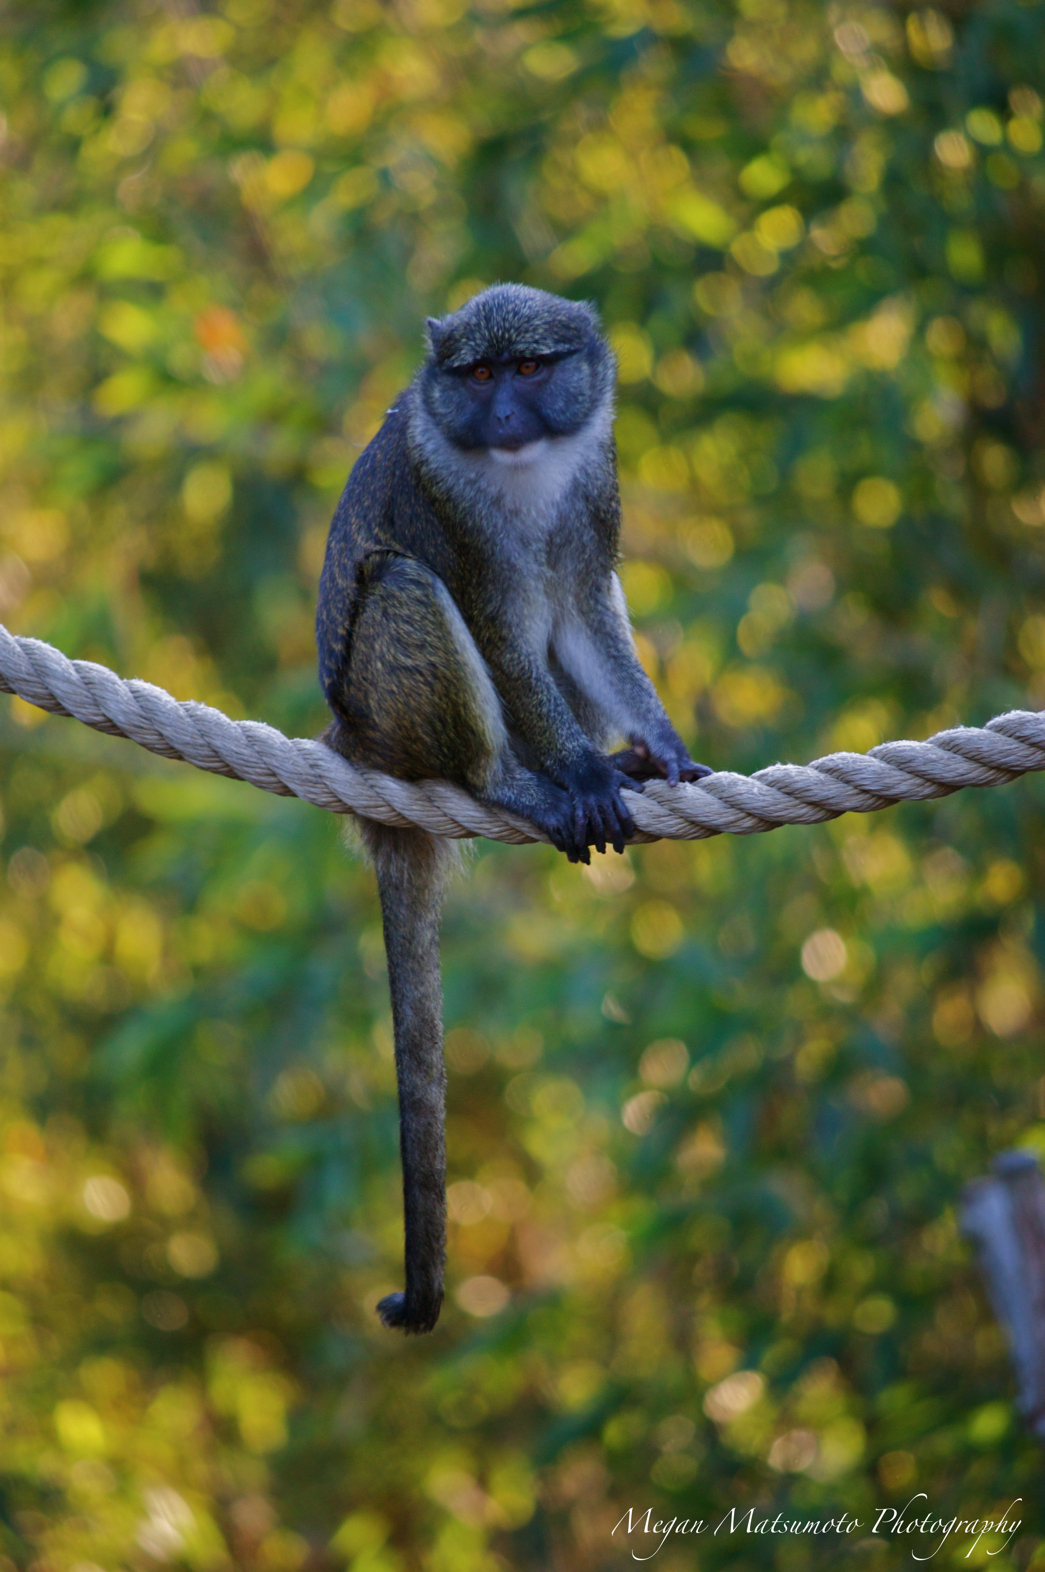](https://www.google.com/url?sa=i&rct=j&q=&esrc=s&source=images&cd=&ved=0ahUKEwjj6qL1xInNAhUHfVIKHUxMBX0QjRwIBw&url=https://mmatsumotophotography.wordpress.com/tag/guenon/&psig=AFQjCNE23jaV3vQF6AEDjKgV_G3_1AGo6Q&ust=1464963570622295)

**Not only that, but there was a large cat.**

[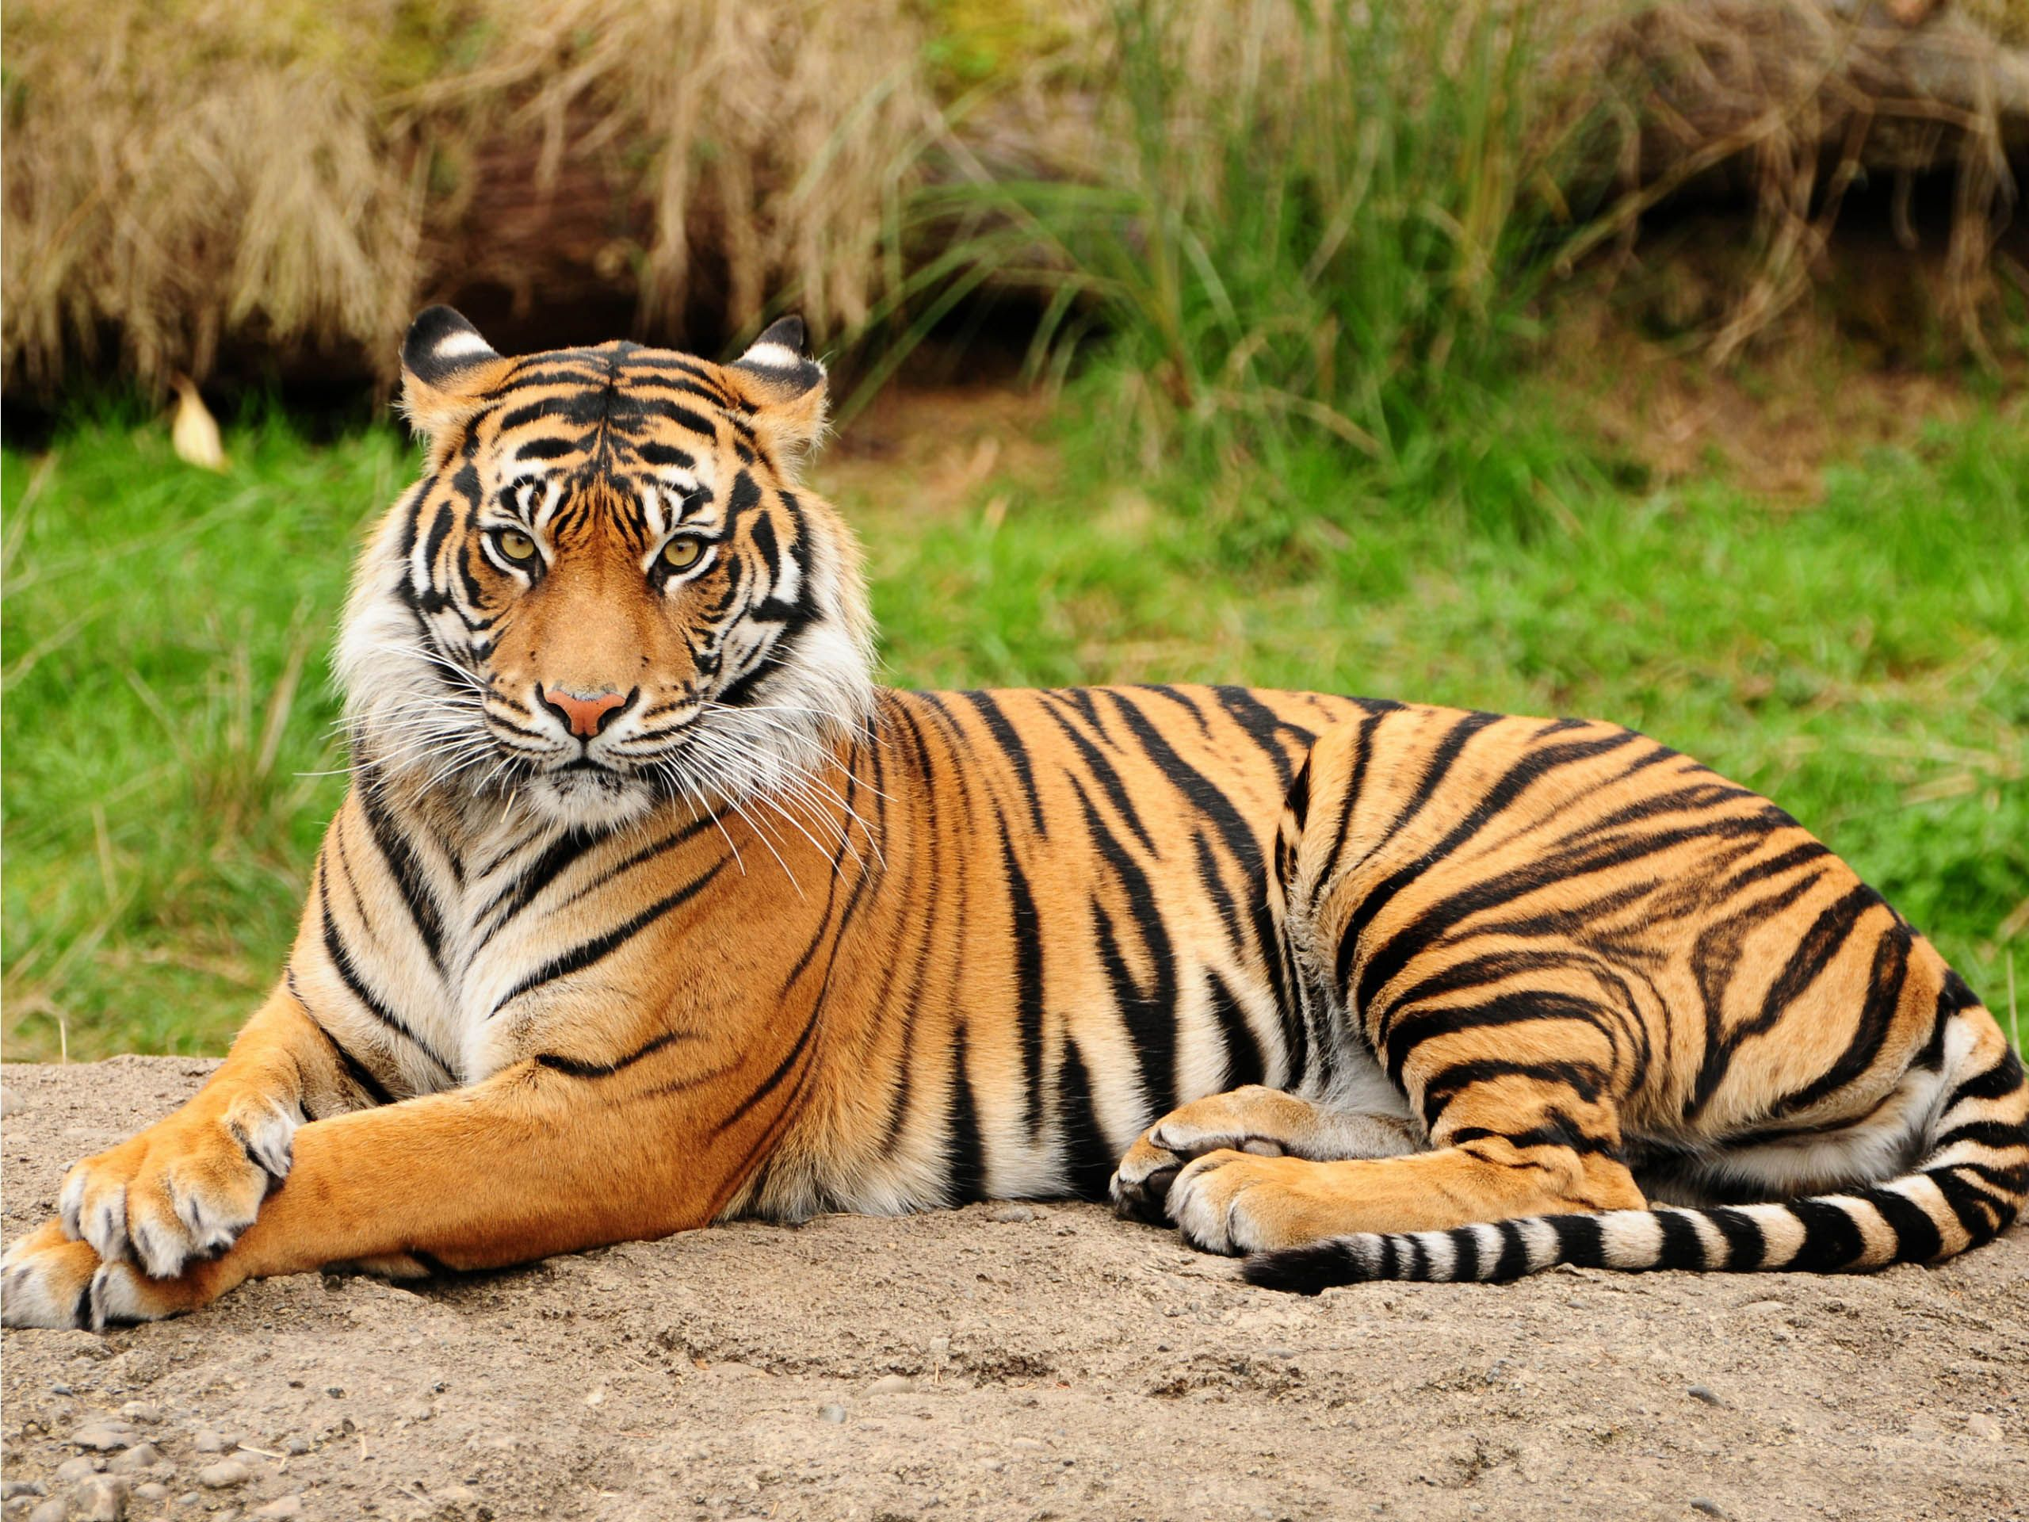](http://www.google.com/url?sa=i&rct=j&q=&esrc=s&source=images&cd=&cad=rja&uact=8&ved=0ahUKEwi93e2nxonNAhULDlIKHfrQB6wQjRwIBw&url=http://www.themescompany.com/2013/12/07/30-most-beautiful-tiger-pictures-that-will-inspire-you/&psig=AFQjCNH_AF_GY3CX2sOI-lpUw29huW5p_g&ust=1464963983804594)

**I went to the fire station and what luck.**

**I saw a giant fire truck.**

[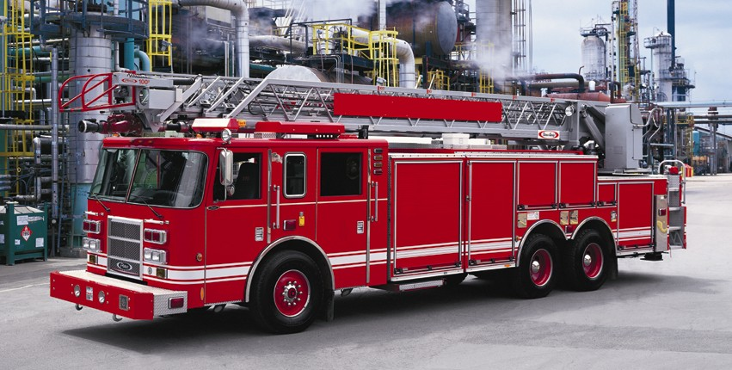](http://www.google.com/url?sa=i&rct=j&q=&esrc=s&source=images&cd=&cad=rja&uact=8&ved=0ahUKEwj4garqx4nNAhVNIlIKHW-9DUQQjRwIBw&url=http://www.drive-awayspecialist.com/apps/photos/photo?photoid%3D193259676&psig=AFQjCNEcqv0r96fHpK7uGZHGZL3iGsz9wg&ust=1464964396685338)

**Ladders so tall and**

**ambulances big and small**

[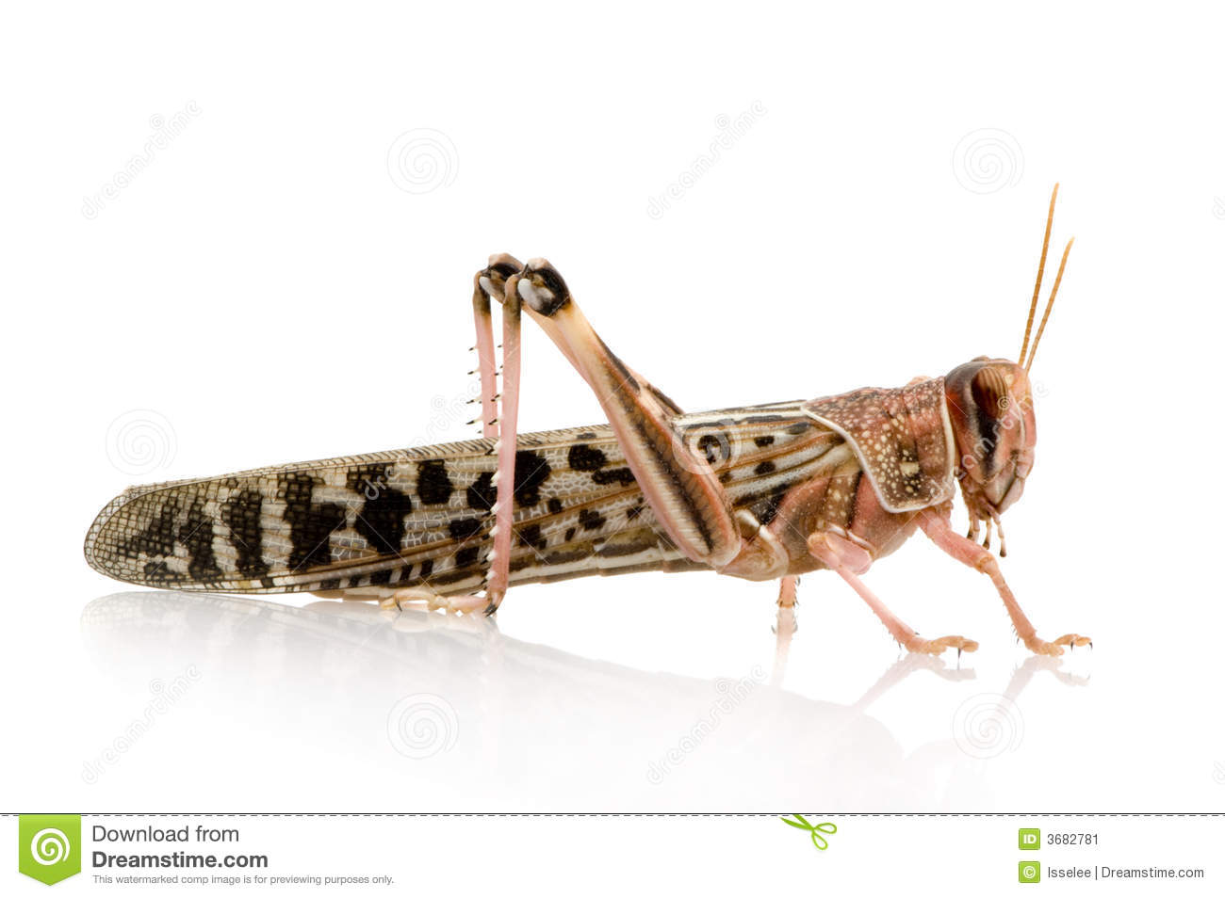](http://www.google.com/url?sa=i&rct=j&q=&esrc=s&source=images&cd=&cad=rja&uact=8&ved=0ahUKEwihwc7Ii-7KAhVBPD4KHSQdD2MQjRwIBw&url=http://www.dreamstime.com/stock-image-desert-locust-schistocerca-gregaria-image3682781&psig=AFQjCNH-JY45YK7nP3xkaHlhqkjANL0DUg&ust=1455223904283648)[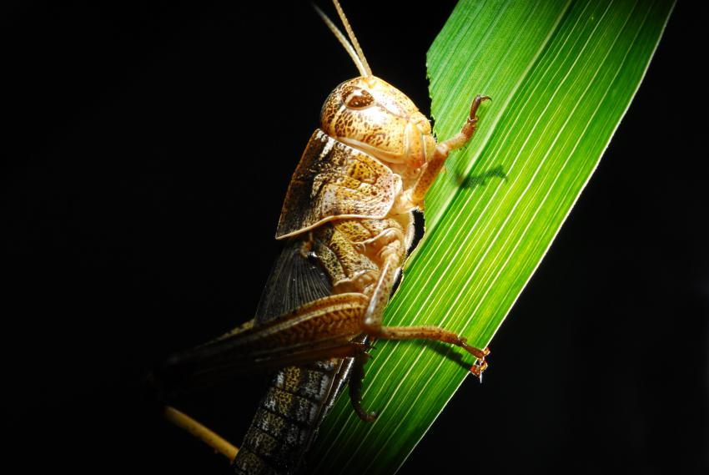](http://www.google.com/url?sa=i&rct=j&q=&esrc=s&source=images&cd=&cad=rja&uact=8&ved=0ahUKEwiTgbGaiu7KAhWMOT4KHVYdCWEQjRwIBw&url=http://phys.org/news/2014-07-locusts-harness-sun-optimum-diet.html&psig=AFQjCNH-JY45YK7nP3xkaHlhqkjANL0DUg&ust=1455223904283648)

**Every hour this made him quite sour.**

**Everyone wanted to keep in touch and it was just too much.**

**He had lost his leap**

**From lack of sleep.**

[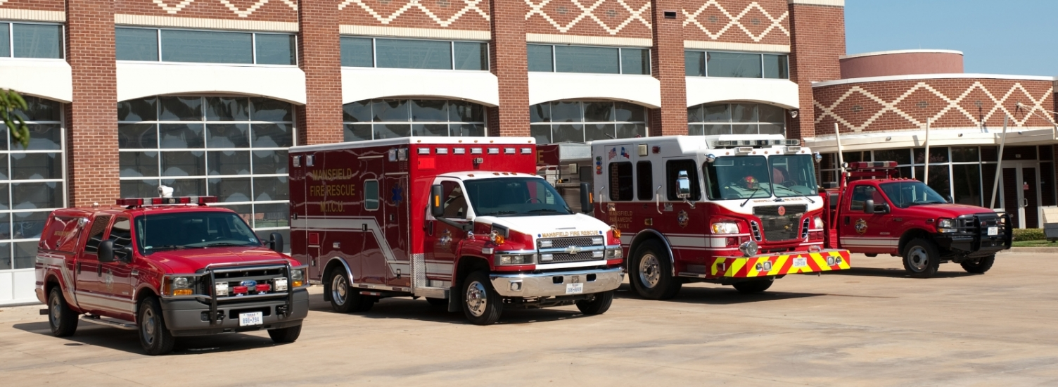](https://www.google.com/url?sa=i&rct=j&q=&esrc=s&source=images&cd=&cad=rja&uact=8&ved=0ahUKEwim2sLfyInNAhVML1IKHVn3CM4QjRwIBw&url=https://www.mansfieldtexas.gov/facility/fire-station-1&psig=AFQjCNETRbCOq_jajRBhXzrdNEQMXy1f4Q&ust=1464964617071029)

**I saw baseball on the TV but it wasn’t the same**

**As going to a real game.**

[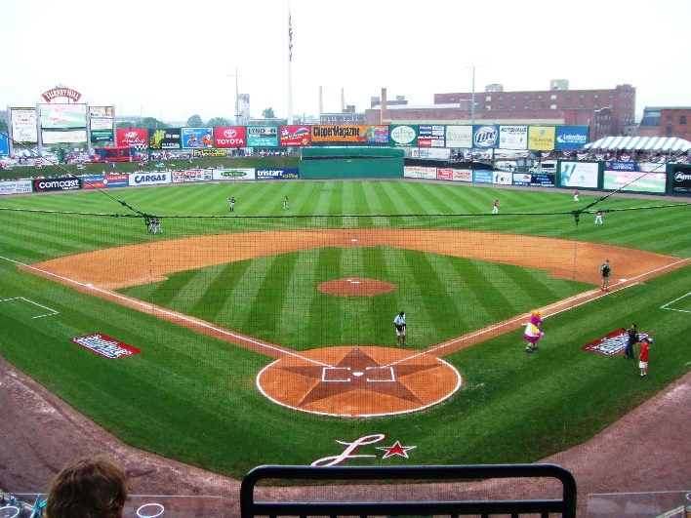](http://www.google.com/url?sa=i&rct=j&q=&esrc=s&source=images&cd=&cad=rja&uact=8&ved=0ahUKEwiytaDMzInNAhUOGlIKHZXoAP8QjRwIBw&url=http://groundskeeper.mlblogs.com/2012/02/27/tips-on-designing-a-professional-baseball-field/&psig=AFQjCNHhPCLuM4nkkZPS5qUZ4jFJ7102SQ&ust=1464965581815154)

[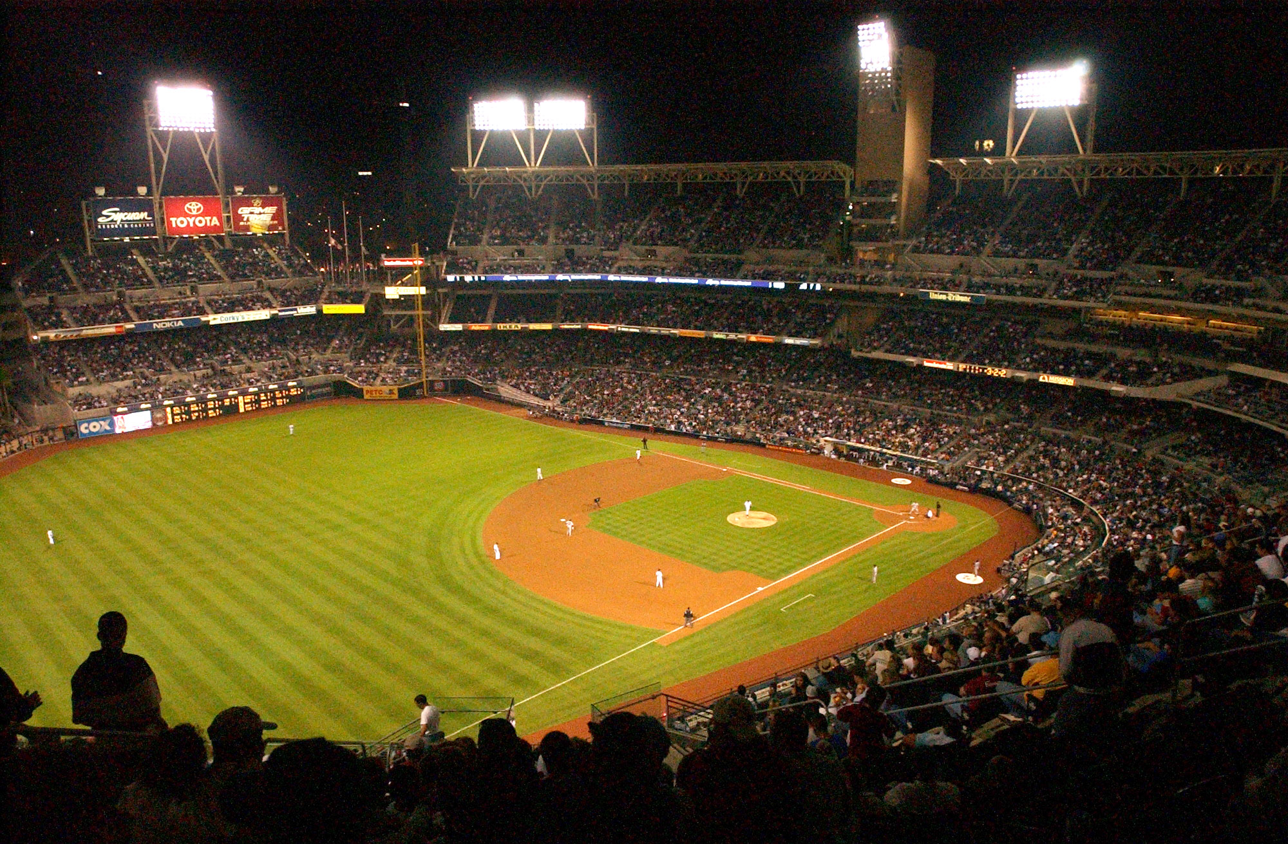](https://www.google.com/url?sa=i&rct=j&q=&esrc=s&source=images&cd=&cad=rja&uact=8&ved=0ahUKEwiDydOuzYnNAhUfFVIKHRKXBBYQjRwIBw&url=https://en.wikipedia.org/wiki/Baseball_field&psig=AFQjCNF3wWHGVr7qsHVaDktvEhxyZOdyzg&ust=1464965778518212)

**Let me say it is very difficult to play.**

[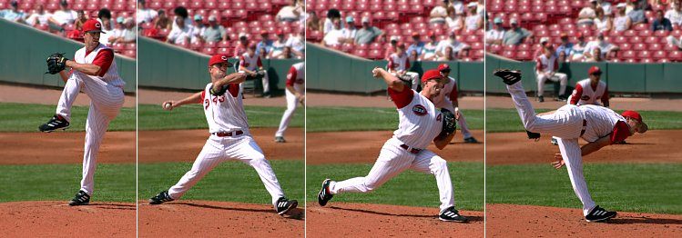](https://www.google.com/url?sa=i&rct=j&q=&esrc=s&source=images&cd=&ved=0ahUKEwjd4PjrzYnNAhUHVlIKHTY4A_gQjRwIBw&url=https://en.wikipedia.org/wiki/Pitch_(baseball)&psig=AFQjCNF3wWHGVr7qsHVaDktvEhxyZOdyzg&ust=1464965778518212)

[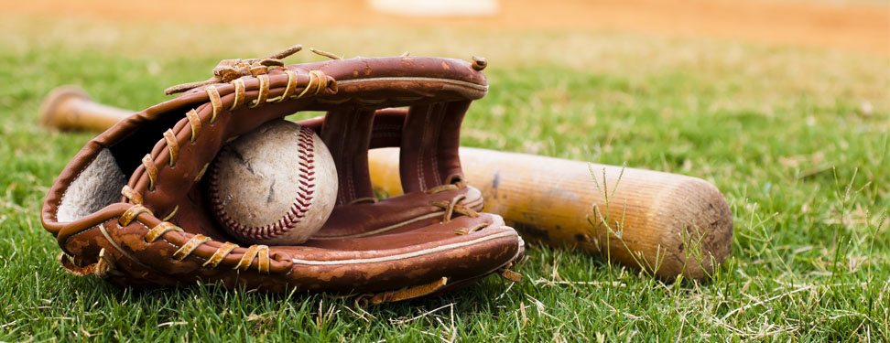](https://www.google.com/url?sa=i&rct=j&q=&esrc=s&source=images&cd=&cad=rja&uact=8&ved=0ahUKEwj7msKBzYnNAhVLOFIKHTZVBZoQjRwIBw&url=https://www.littlerockchristian.com/athletics/sports-programs/baseball&psig=AFQjCNF3wWHGVr7qsHVaDktvEhxyZOdyzg&ust=1464965778518212)



I have played catch in my yard and it is very hard.

Insert photo if available

**In the fall I tried football!**

[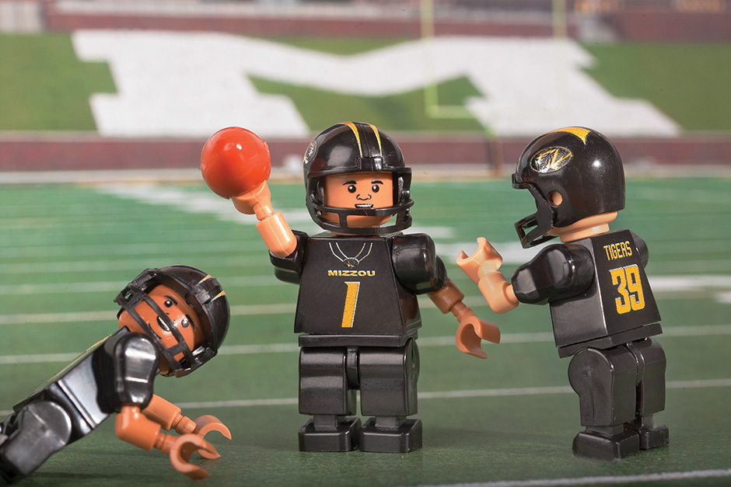](https://www.google.com/url?sa=i&rct=j&q=&esrc=s&source=images&cd=&cad=rja&uact=8&ved=0ahUKEwi0vc6P7sjNAhVC6yYKHUNMAc8QjRwIBw&url=https%3A%2F%2Fmizzoumag.missouri.edu%2F2015%2F08%2Fmaking-mizzou-made%2F&bvm=bv.125596728,d.dmo&psig=AFQjCNHYObbwv2QNwThBhqi5pWMxd9h1jA&ust=1467139255721644)

Of course it is very cool at my pool.

[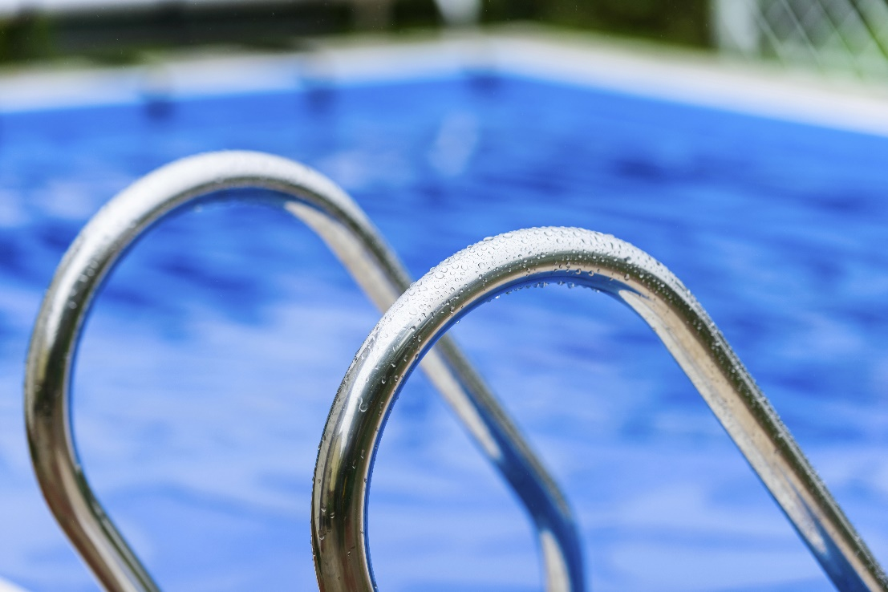](http://www.google.com/url?sa=i&rct=j&q=&esrc=s&source=images&cd=&cad=rja&uact=8&ved=0ahUKEwiE9v73horNAhUCSVIKHeDEA98QjRwIBw&url=http://www.allencountyhealth.com/get-licensed/public-and-semi-public-pools-and-spas/&psig=AFQjCNEA3dspe_4yH2FKI2-qPmGa6vp9nw&ust=1464981281616876)

When it’s hotter

My friends like the water.

**Sometimes a lake**

**For goodness sake.**

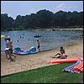

[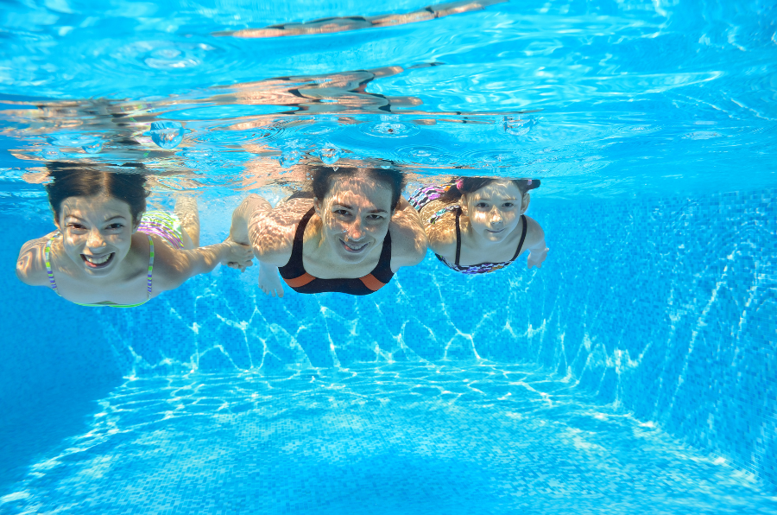](https://www.google.com/url?sa=i&rct=j&q=&esrc=s&source=images&cd=&ved=0ahUKEwiFqaWtiIrNAhVBLlIKHYJ_DoMQjRwIBw&url=https://www.consumeraffairs.com/swimming-pools-and-pool-safety&psig=AFQjCNEA3dspe_4yH2FKI2-qPmGa6vp9nw&ust=1464981281616876)

**This year I played soccer**

**It’s a lot of run and fun**

**for girls and boys.**



[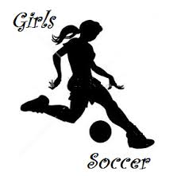](https://www.google.com/url?sa=i&rct=j&q=&esrc=s&source=images&cd=&ved=0ahUKEwiRi9WskYrNAhUZFVIKHUdwAwMQjRwIBw&url=https://lahs.ggusd.us/?p%3D2798&psig=AFQjCNFYcy3eQBfjxKXEv5Y9iMyI71zrZQ&ust=1464984112166697&cad=rjt)

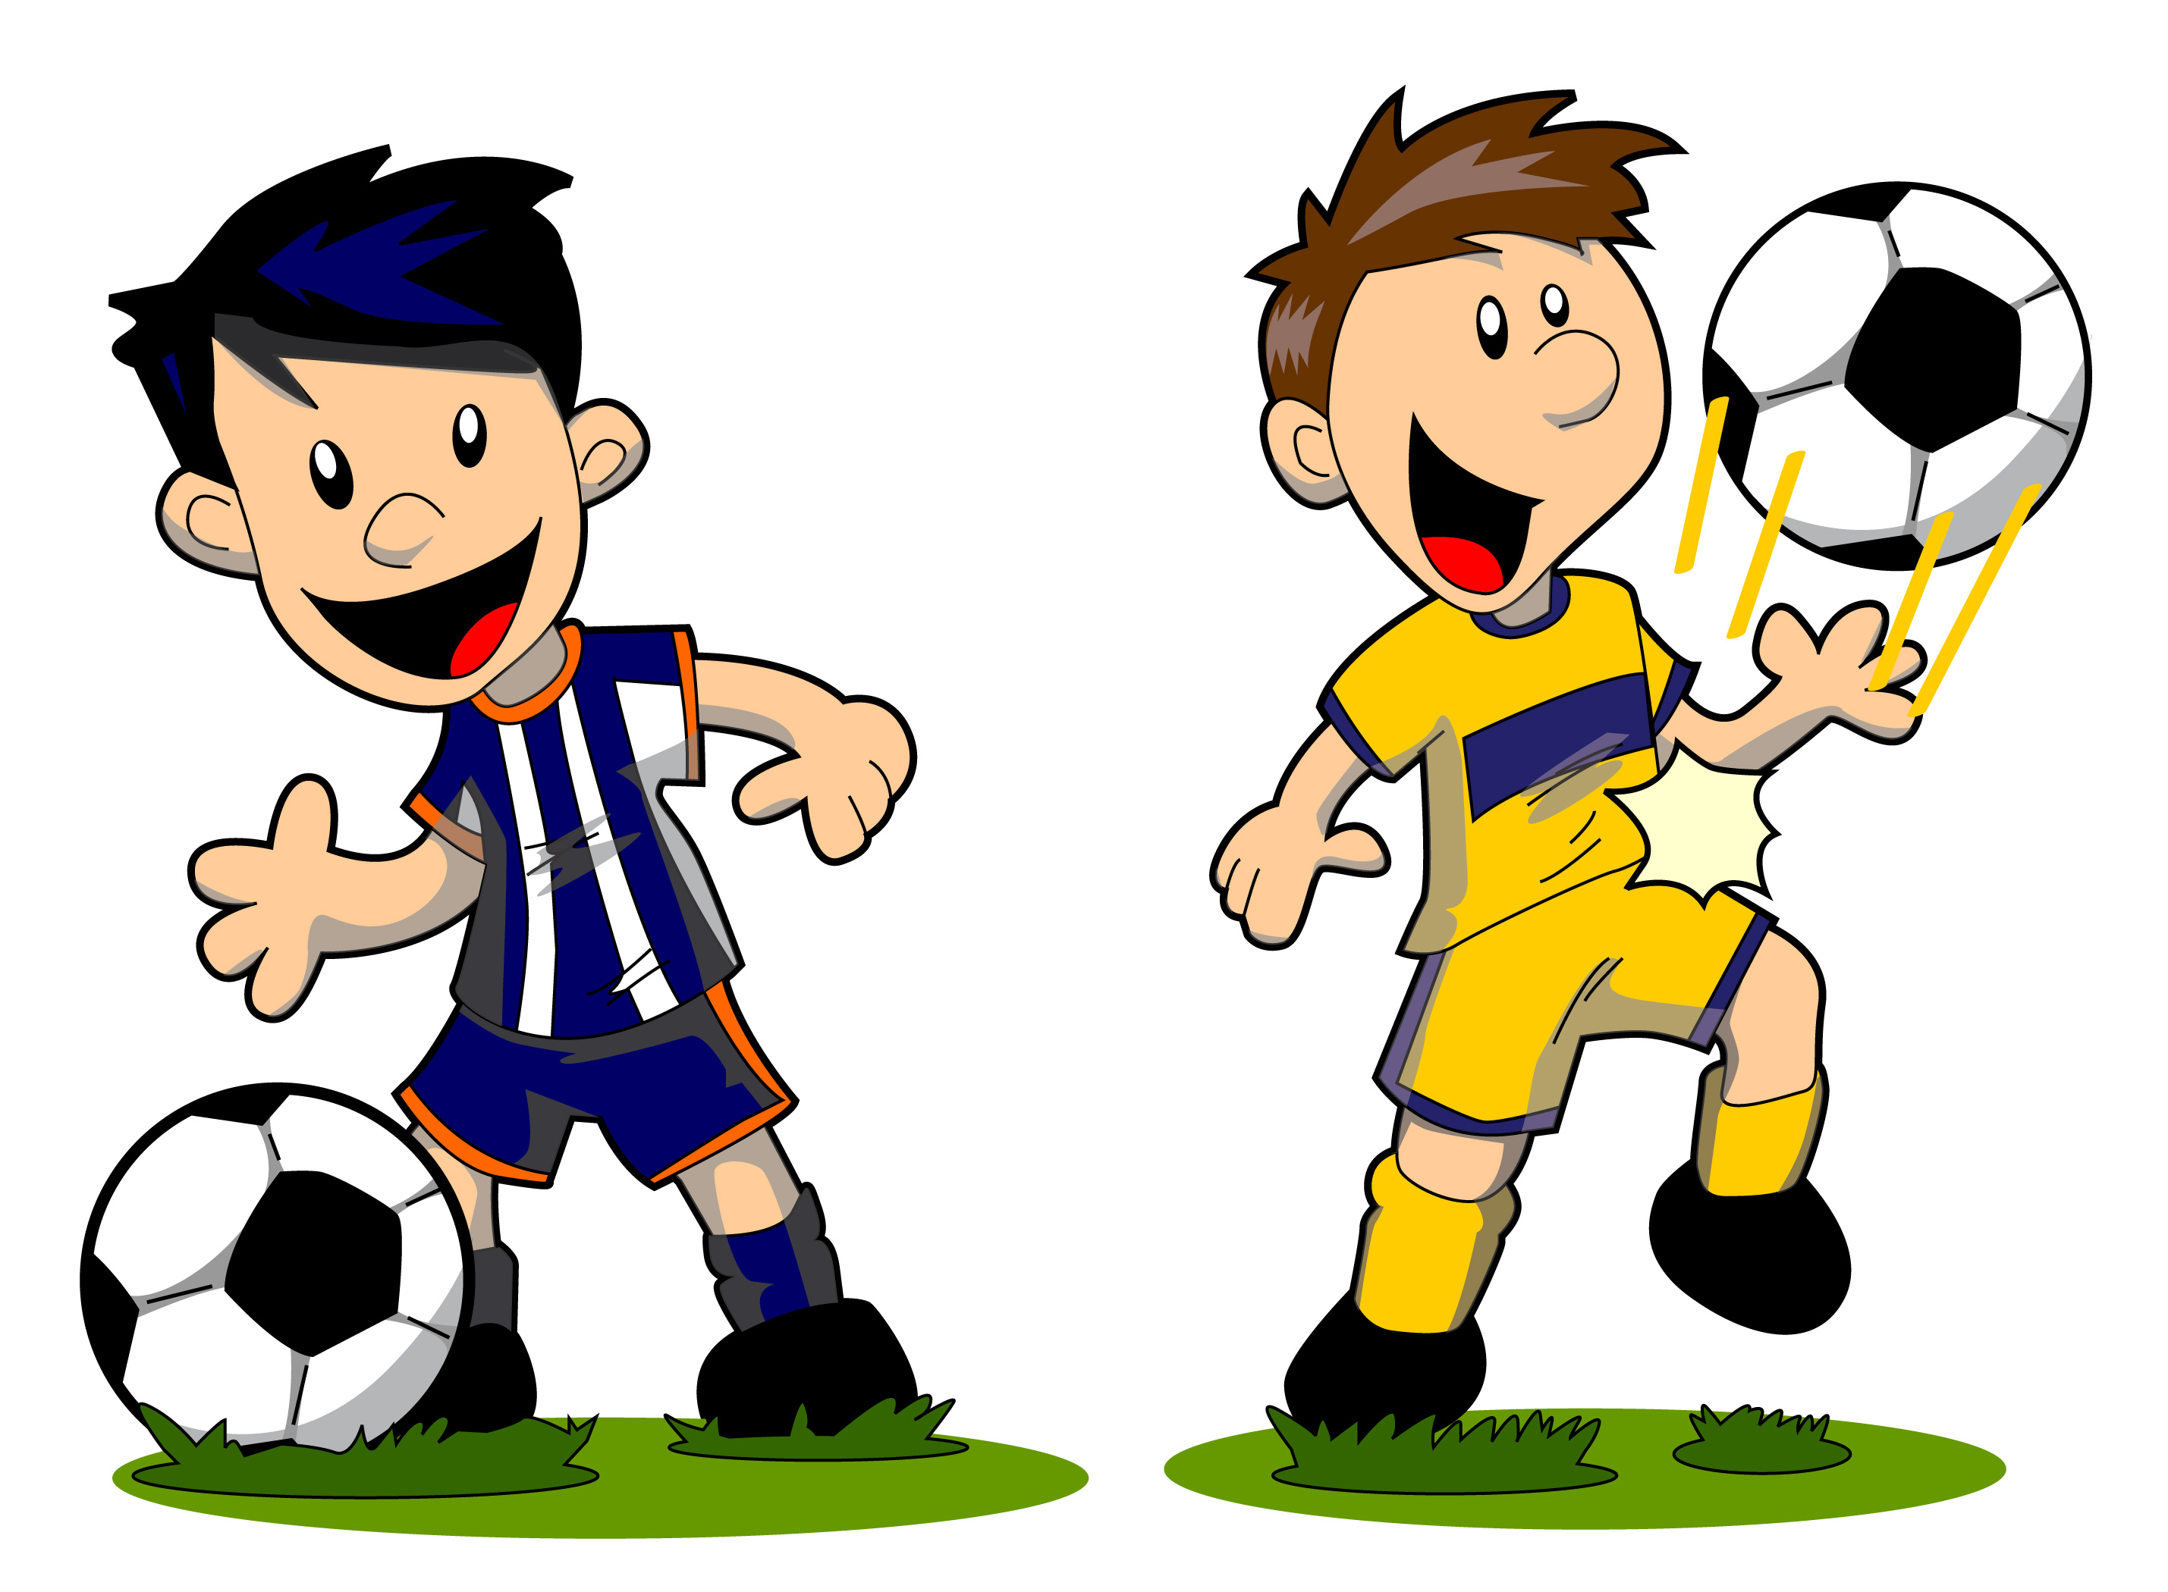

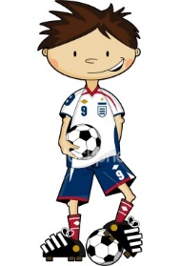

**I am quick and I can dribble and kick.**

Insert if you have a child’s soccer photo.

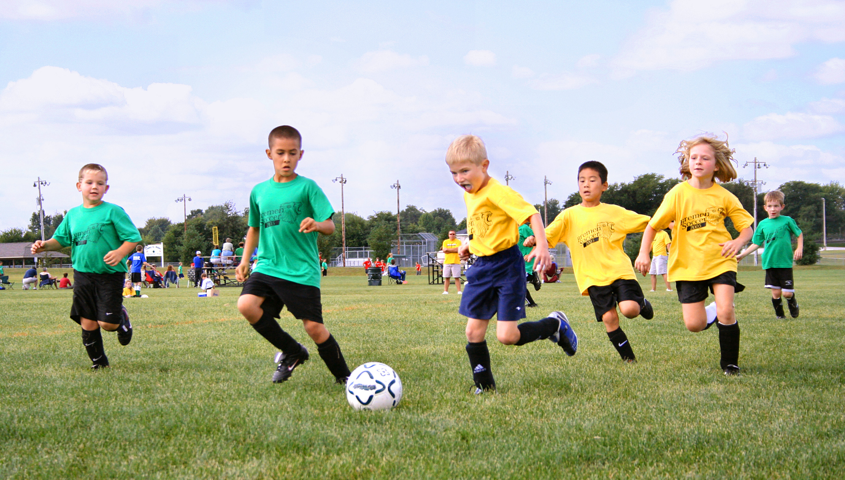

**I LOVE TO RUN IN THE SUN.**

[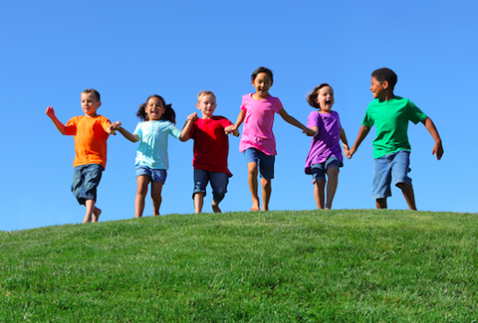](http://www.google.com/url?sa=i&rct=j&q=&esrc=s&source=images&cd=&cad=rja&uact=8&ved=0ahUKEwjyp5fS88jNAhUiwYMKHZU7A7MQjRwIBw&url=http%3A%2F%2Forem.alpineschools.org%2Fwp-content%2Fuploads%2Fsites%2F37%2F2014%2F06%2F&bvm=bv.125596728,d.dmo&psig=AFQjCNEO0VvcsZ2xjKLm_NajGZv9EIFXRg&ust=1467140824149084)

**I GO TO THE PARK**

**DURING THE DAY, NOT IN THE DARK.**

**IT’S Also A FUN THING**

**TO GO HIGH ON A SWING**

[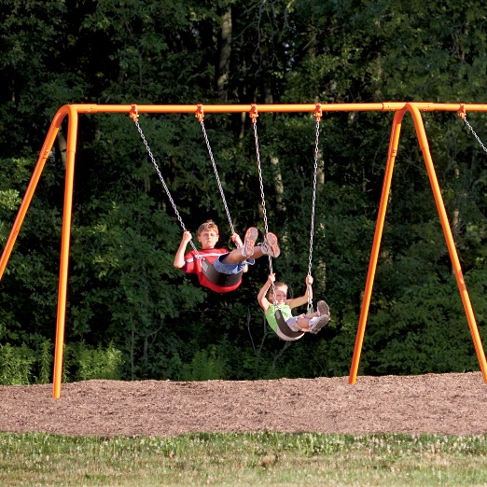](http://www.google.com/url?sa=i&rct=j&q=&esrc=s&source=images&cd=&cad=rja&uact=8&ved=0ahUKEwj_m-GTmorNAhUNFVIKHf4GBZ4QjRwIBw&url=http://www.aaastateofplay.com/swingsets/&psig=AFQjCNE8n7e9JEUmu_E9mdQHTkIJzFDg-Q&ust=1464986493243839)

[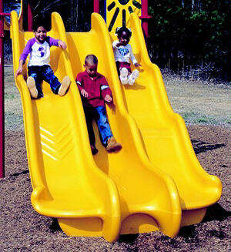](http://www.google.com/url?sa=i&rct=j&q=&esrc=s&source=images&cd=&cad=rja&uact=8&ved=0ahUKEwio3ZHUmorNAhUOXVIKHbQ7Aj0QjRwIBw&url=http://www.detailedplaypro.com/playground-slides.htm&psig=AFQjCNG-ZY23IlbcfneEXjpskCFepOKiDg&ust=1464986636913716)

**AND EVEN SLIDE.**

[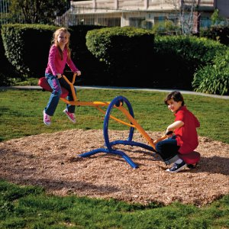](http://www.hayneedle.com/product/gymdandyteetertotter.cfm?ltype=child&tid=IPX100-1)

**When it’s hotter**

**Teetooter**

My Family Went

On…



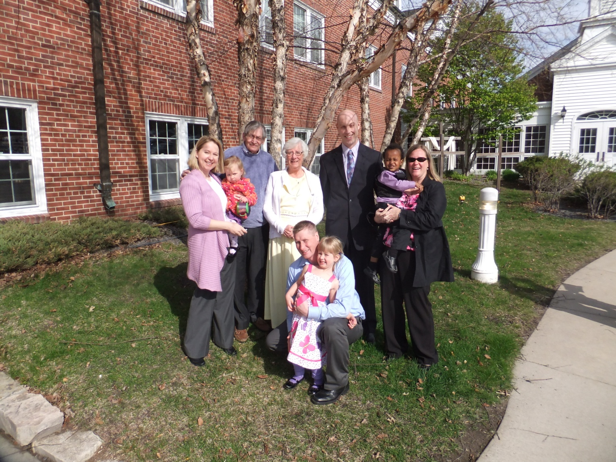

Insert family photo

We went to Florida

**Some of the things I did were easy, some tough.**

**But we were on vacation doing lots of stuff.**



**Photos**

**All I can say is we had great time to play**

Add vacation photos. Use as many pages as you have good pictures.

I went to birthday parties for goodness sake.

We had ice cream and cake.

[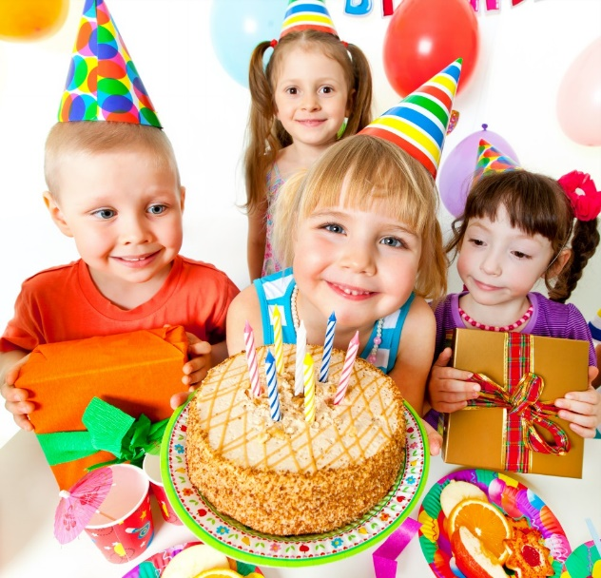](http://www.google.com/url?sa=i&rct=j&q=&esrc=s&source=images&cd=&cad=rja&uact=8&ved=0ahUKEwj2m7iAsObMAhWBTyYKHcfsC6AQjRwIBw&url=http://3tallstars.com/birthday-parties/&psig=AFQjCNGVNwhpFOe0rGopkWHZ2Lxo5D6Q-Q&ust=1463755412986208)

Inset photo if available.

**Let’s Party Hardy!**

[](http://www.google.com/url?sa=i&rct=j&q=&esrc=s&source=images&cd=&cad=rja&uact=8&ved=0ahUKEwj__ayO8rvMAhUKmoMKHZ2BDdsQjRwIBw&url=http://www.debifeinman.com/tag/birthday/&psig=AFQjCNGyRuBaPQCoI028DHiatibfn8YSEA&ust=1462295603273000)

**I went to a fair-carnival**

**There was lots of food if you were in the mood.**

**There was a Ferris wheel with lights to shine during the nights.**

**Scary rides on all sides.**

**There were games and shows and what else who knows.**

**We even found a merry-go-around.**

[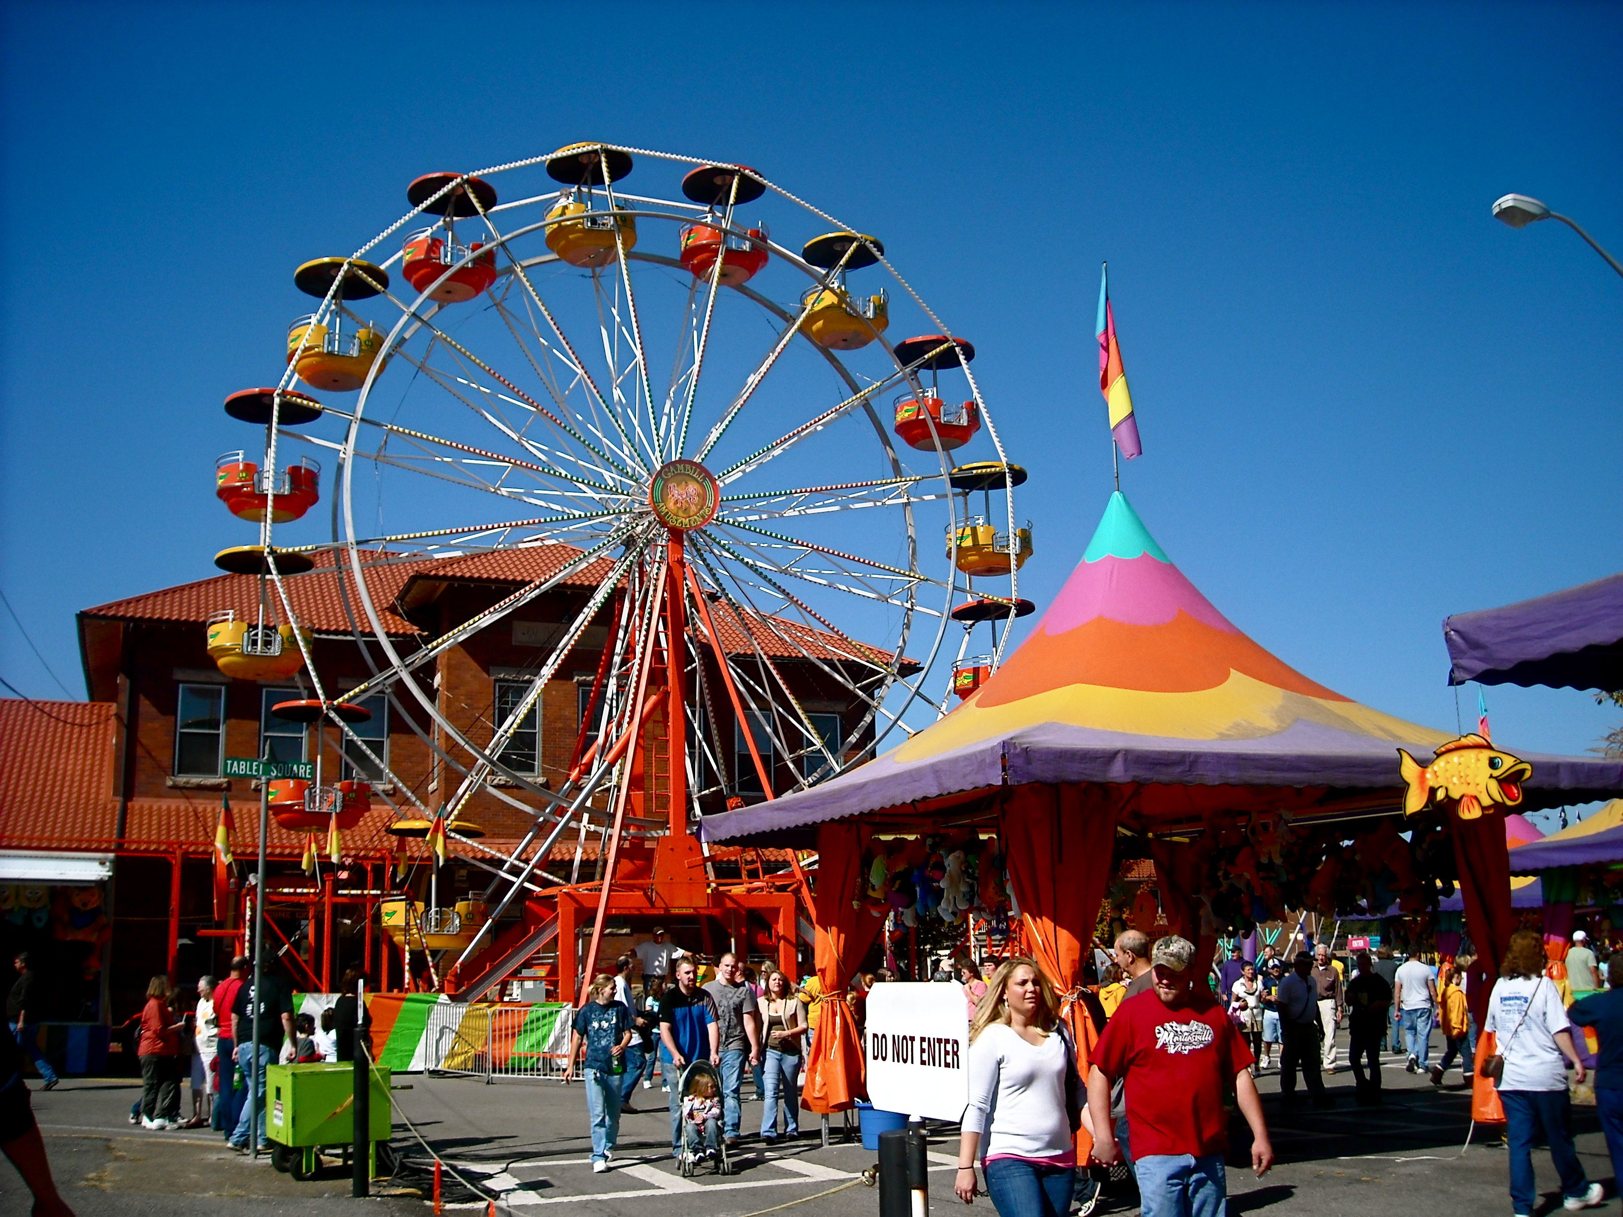](http://www.google.com/url?sa=i&rct=j&q=&esrc=s&source=images&cd=&cad=rja&uact=8&ved=0ahUKEwi19_HvmJnNAhVGOVIKHV1VBU4QjRwIBw&url=http://sf.funcheap.com/annual-3-day-cupertino-carnival/&bvm=bv.124088155,d.amc&psig=AFQjCNGmadiP7u-6k6RPGhlz3u47hr4YIw&ust=1465501541988335)

[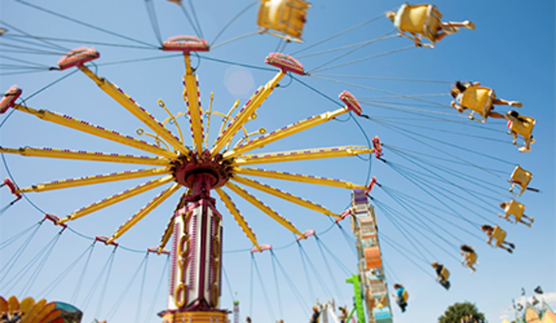](http://www.google.com/url?sa=i&rct=j&q=&esrc=s&source=images&cd=&cad=rja&uact=8&ved=0ahUKEwic3cnOmJnNAhVEDlIKHYFmBlUQjRwIBw&url=http://www.illinois.gov/idol/Rides&bvm=bv.124088155,d.amc&psig=AFQjCNFjN189gWjLDbEkdGIwO5aYAMkpNQ&ust=1465501476190038)

[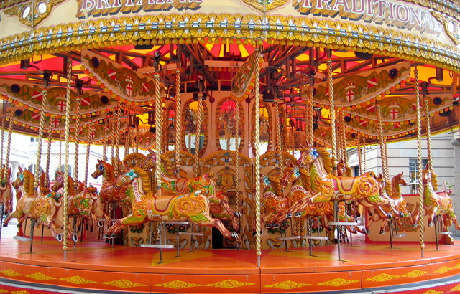](http://www.google.com/url?sa=i&rct=j&q=&esrc=s&source=images&cd=&cad=rja&uact=8&ved=0ahUKEwj3xKOumZnNAhUBa1IKHU2BCTIQjRwIBw&url=http://kit-johnson.com/roller-coaster-or-merry-go-round/&psig=AFQjCNFi-CMgSnJF7l3-s5WYBeVgILd7AA&ust=1465501683404758)

**“Trick or treat, money or eat.”**

**Halloween.**

**It was just dandy collecting candy.**

My costume was a

Scarry monster. [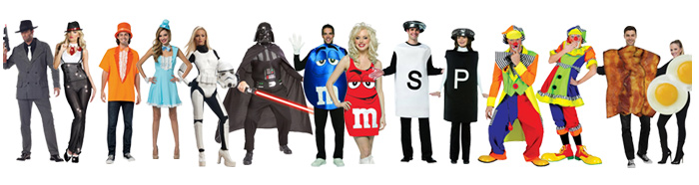](http://www.google.com/url?sa=i&rct=j&q=&esrc=s&source=images&cd=&cad=rja&uact=8&ved=0ahUKEwimkrmeoPrKAhXjnIMKHVb3DZsQjRwIBw&url=http://www.halloweenexpress.com/couples-costume-ideas.php&psig=AFQjCNHYhhcB1JJrHABHxsj252q2--KV2Q&ust=1455641310633993)

**“It would be a sin**

**If we didn’t carve a pumpkin.”**

**So I did!**

[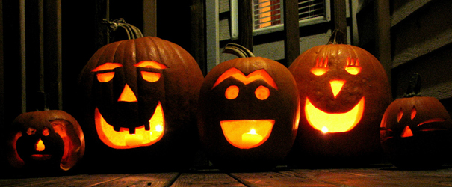](http://www.google.com/url?sa=i&rct=j&q=&esrc=s&source=images&cd=&cad=rja&uact=8&ved=0ahUKEwiJ3oCLsvrKAhXJwj4KHajvDAIQjRwIBw&url=http://athensohio.com/blog-posts/in-search-of-the-6-best-pumpkin-patches-near-athens/&psig=AFQjCNFW3ytdV-MqSy_A3V2NFrGWiIYLYg&ust=1455646973518184)

I went to gymnastics

The beam is not as easy as it would seen

[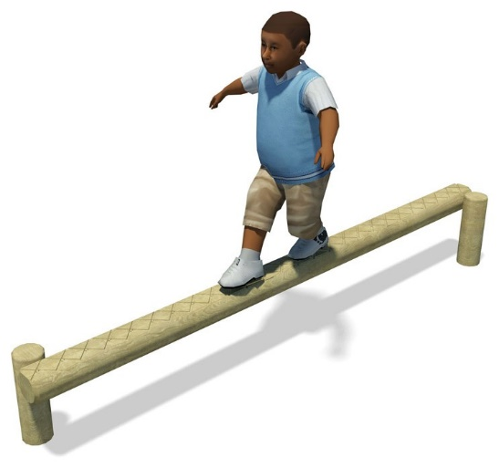](https://www.google.com/url?sa=i&rct=j&q=&esrc=s&source=images&cd=&cad=rja&uact=8&ved=0ahUKEwiZveHAsZnNAhURM1IKHRvgDLEQjRwIBw&url=https://www.playdale.co.uk/playground/single-balance-beam.html&psig=AFQjCNGMdOq53nB9rA3EVzMPjmnK4cn2ZQ&ust=1465508169427726) [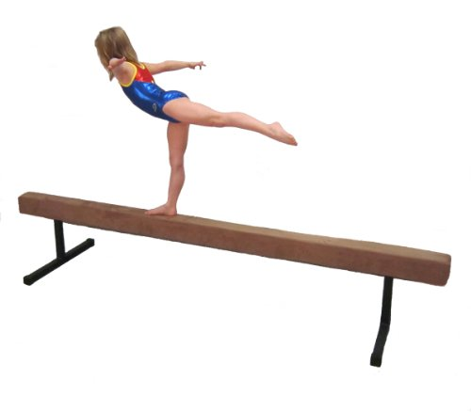](http://www.google.com/url?sa=i&rct=j&q=&esrc=s&source=images&cd=&cad=rja&uact=8&ved=0ahUKEwiP9vPlsZnNAhVGJFIKHWrvCmwQjRwIBw&url=http://www.madeintheusa.com/B006DDKUQ2-Balance-Beam--BB1612-Padded-Suede-16-Foot-Balance-Beam-Tan-with-12-Riser-Legs&bvm=bv.124088155,d.aXo&psig=AFQjCNE21PQHyNw7S6LeTi9Au7PBQDeZZA&ust=1465508242802226)

And of course

There were mats and a horse.

[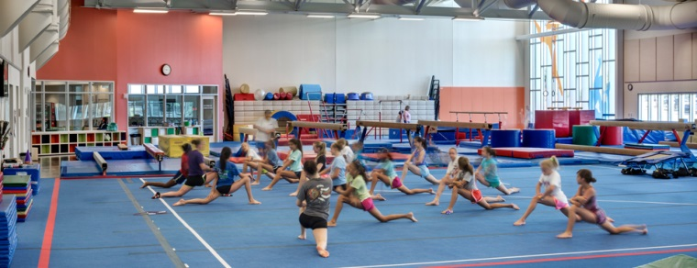](http://www.google.com/url?sa=i&rct=j&q=&esrc=s&source=images&cd=&cad=rja&uact=8&ved=0ahUKEwi_qpn_s5nNAhUPTlIKHdZkBUYQjRwIBw&url=http://www.cor.net/index.aspx?page%3D38&psig=AFQjCNF4YgxqA42Y0oHuF0FPhXtyCdmk7Q&ust=1465508769223702)

**Then there was the time I went to a theater show.**

**It cost some money**

**and the actors were funny.**



**The actors made everything seem like now and at the end took a bow.**

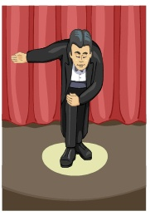

**My ________ took me to the movies**

**It was very neat to have a treat**

**The seats were mushy – cushy.**

[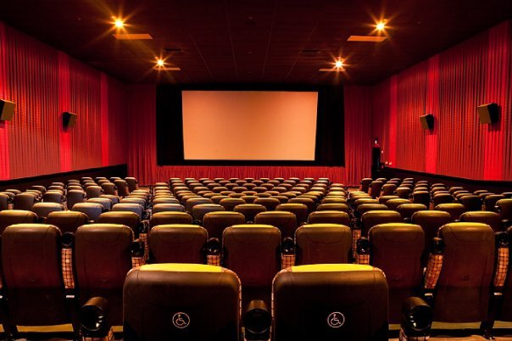](https://www.google.com/url?sa=i&rct=j&q=&esrc=s&source=images&cd=&cad=rja&uact=8&ved=0ahUKEwigp5zp1pvNAhUSW1IKHeQdAbwQjRwIBw&url=https://www.thrillist.com/drink/nation/brews-with-a-view-a-coast-to-coast-guide-to-movie-theaters-you-can-drink-in&psig=AFQjCNFMPWBoM7-SNFI--lOzuZ8KtXX2Rw&ust=1465586853240017)

[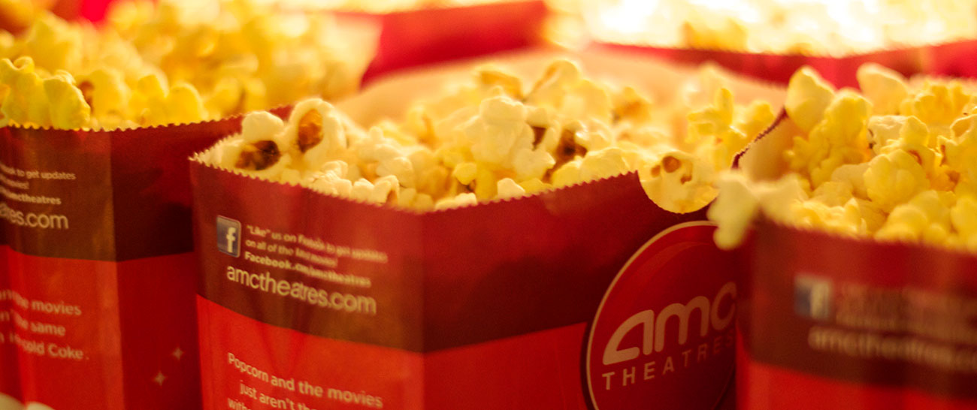](https://www.google.com/url?sa=i&rct=j&q=&esrc=s&source=images&cd=&cad=rja&uact=8&ved=0ahUKEwj5-KC215vNAhUKXVIKHRXOB2YQjRwIBw&url=https://www.amctheatres.com/movie-theatres/philadelphia/amc-plymouth-meeting-mall-12&bvm=bv.124088155,d.aXo&psig=AFQjCNERDJZykSRk8rr6xdlgsHCkBfeZZQ&ust=1465587053358422)

**The popcorn smell**

**was swell.**

[](https://www.google.com/url?sa=i&rct=j&q=&esrc=s&source=images&cd=&cad=rja&uact=8&ved=0ahUKEwiQruqLgPDKAhVHKCYKHTkUDA4QjRwIBw&url=https://pixabay.com/en/news-globe-earth-world-507772/&psig=AFQjCNGzDtyttPMHDcCtPZHOpcLxAlgy0g&ust=1455290038426286)

Flash

**“Going to the doctor I was wary**

**It can be a little scary.**

[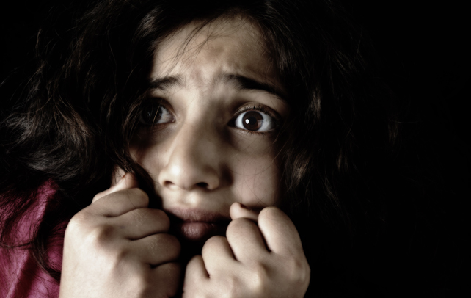](http://www.google.com/url?sa=i&rct=j&q=&esrc=s&source=images&cd=&cad=rja&uact=8&ved=0ahUKEwiCg-qZrPDKAhXJ5CYKHX2HCxQQjRwIBw&url=http://www.playbuzz.com/alfiew10/whats-your-biggest-fear&psig=AFQjCNGfhswZZqBD9zS1QKrV9QqkHFx1-g&ust=1455301898514299)

**All I can say is**

**It was OK.**

**We went outside to camp.**

**We had some food and a lamp.**

**I slept very sound Even though**

**I was on the ground.**

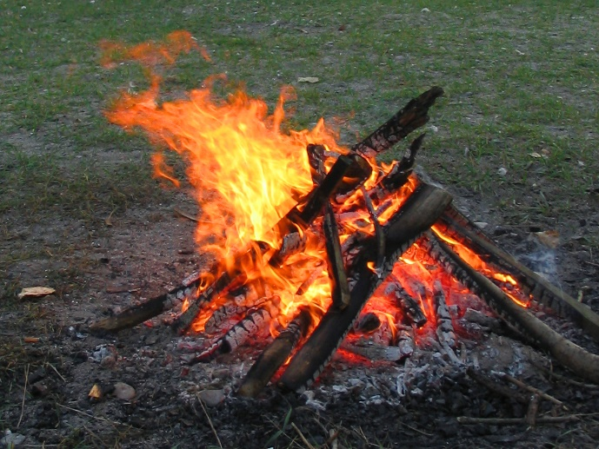

[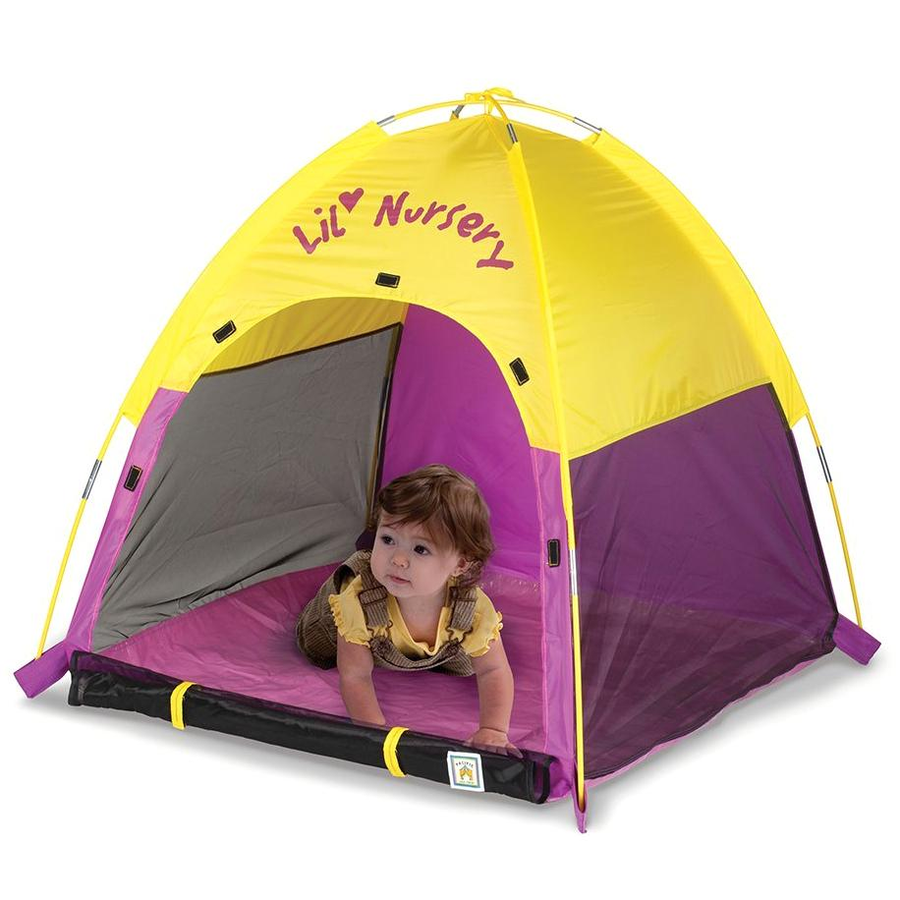](http://www.google.com/url?sa=i&rct=j&q=&esrc=s&source=images&cd=&cad=rja&uact=8&ved=0ahUKEwi0-ImB6Z3NAhVLVlIKHZU8BO8QjRwIBw&url=http://www.amazon.com/Pacific-Play-Tents-Nursery-Tent/dp/B00000IUXC&psig=AFQjCNGqxStaL9gayKnP80Cv0Fuo7mo8vw&ust=1465660485544248)

**We had a fire, ate s’mores, used our flashlight, looked at the stars, told stories, pumped up my air mattress, checked for rain, ate candy, had some water, heard the birds and the bugs, and after a while fell into a deep sleep.**

Edit Activities

[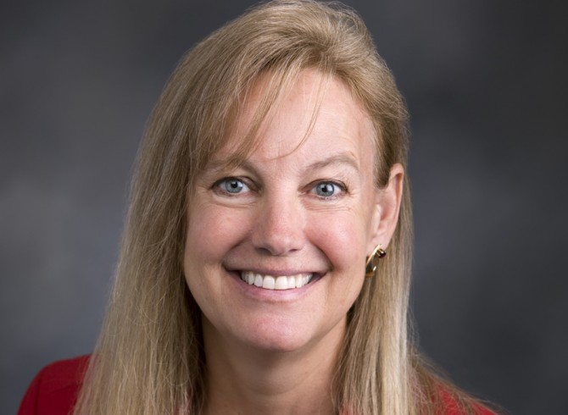](http://www.google.com/url?sa=i&rct=j&q=&esrc=s&source=images&cd=&cad=rja&uact=8&ved=0ahUKEwjnvrnvxYzMAhUGFT4KHS6ZDJkQjRwIBw&url=http://www.inquisitr.com/2722187/mary-dye-virginity/&psig=AFQjCNElwR2572M16tuYfrrzLuesFnGjDQ&ust=1460668728758324)

**With my Mom I went shopping.**

**We drove to the mall without stopping.**

[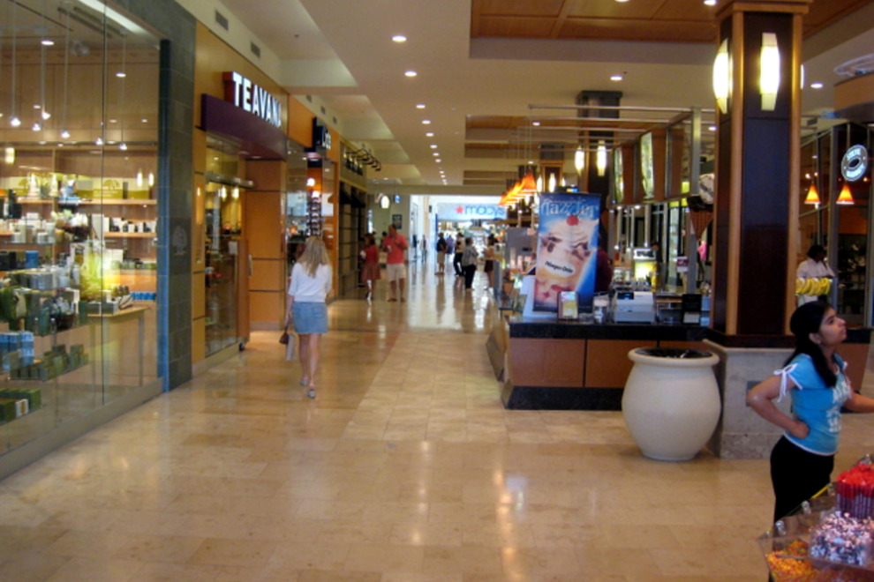](http://www.google.com/url?sa=i&rct=j&q=&esrc=s&source=images&cd=&cad=rja&uact=8&ved=0ahUKEwjairLW7p3NAhVRKlIKHb2MADkQjRwIBw&url=http://www.10best.com/destinations/north-carolina/charlotte/shopping/shopping-centers-districts/&bvm=bv.124088155,d.aXo&psig=AFQjCNFNe9P3IeVeZinKMB4qQ1ZHntxspw&ust=1465662017730607)

**It was huge but we found our store. It had everything and more.**

**It had a food court.**

**It was a feat to choose what to eat.**

[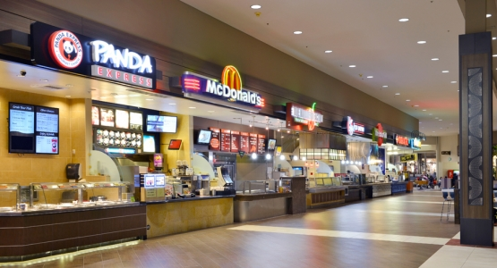](http://www.google.com/url?sa=i&rct=j&q=&esrc=s&source=images&cd=&cad=rja&uact=8&ved=0ahUKEwjQrP_g753NAhUIDlIKHZ8OD0EQjRwIBw&url=http://simspatrickstudio.com/what-we-do/retail/bellis-fair-mall-bellingham-washington/&bvm=bv.124088155,d.aXo&psig=AFQjCNHmHWF4gPeNoLTU1IyxLFd4Wc4PEw&ust=1465662313856576)

**It was kind of fun**

**but I walked a ton.**

**We walked very far**

**And then some to find our car.**

.

**Presents we found. They were all around.**

**I helped Cook**

**and not from a book.**

**I helped make a cake for goodness sake**

[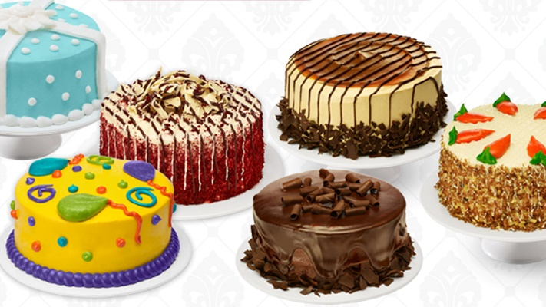](http://www.google.com/url?sa=i&rct=j&q=&esrc=s&source=images&cd=&cad=rja&uact=8&ved=0ahUKEwjdxvij3PLKAhVCPiYKHQUyAjsQjRwIBw&url=http://fox59.com/2013/07/30/cake-boss-coming-to-indy-giving-away-10000-cakes-on-monument-circle/&psig=AFQjCNGthMCUXpFST0XxJkSvf53RjbWxSg&ust=1455383514853370)

**Also my dinner was a winner.**

[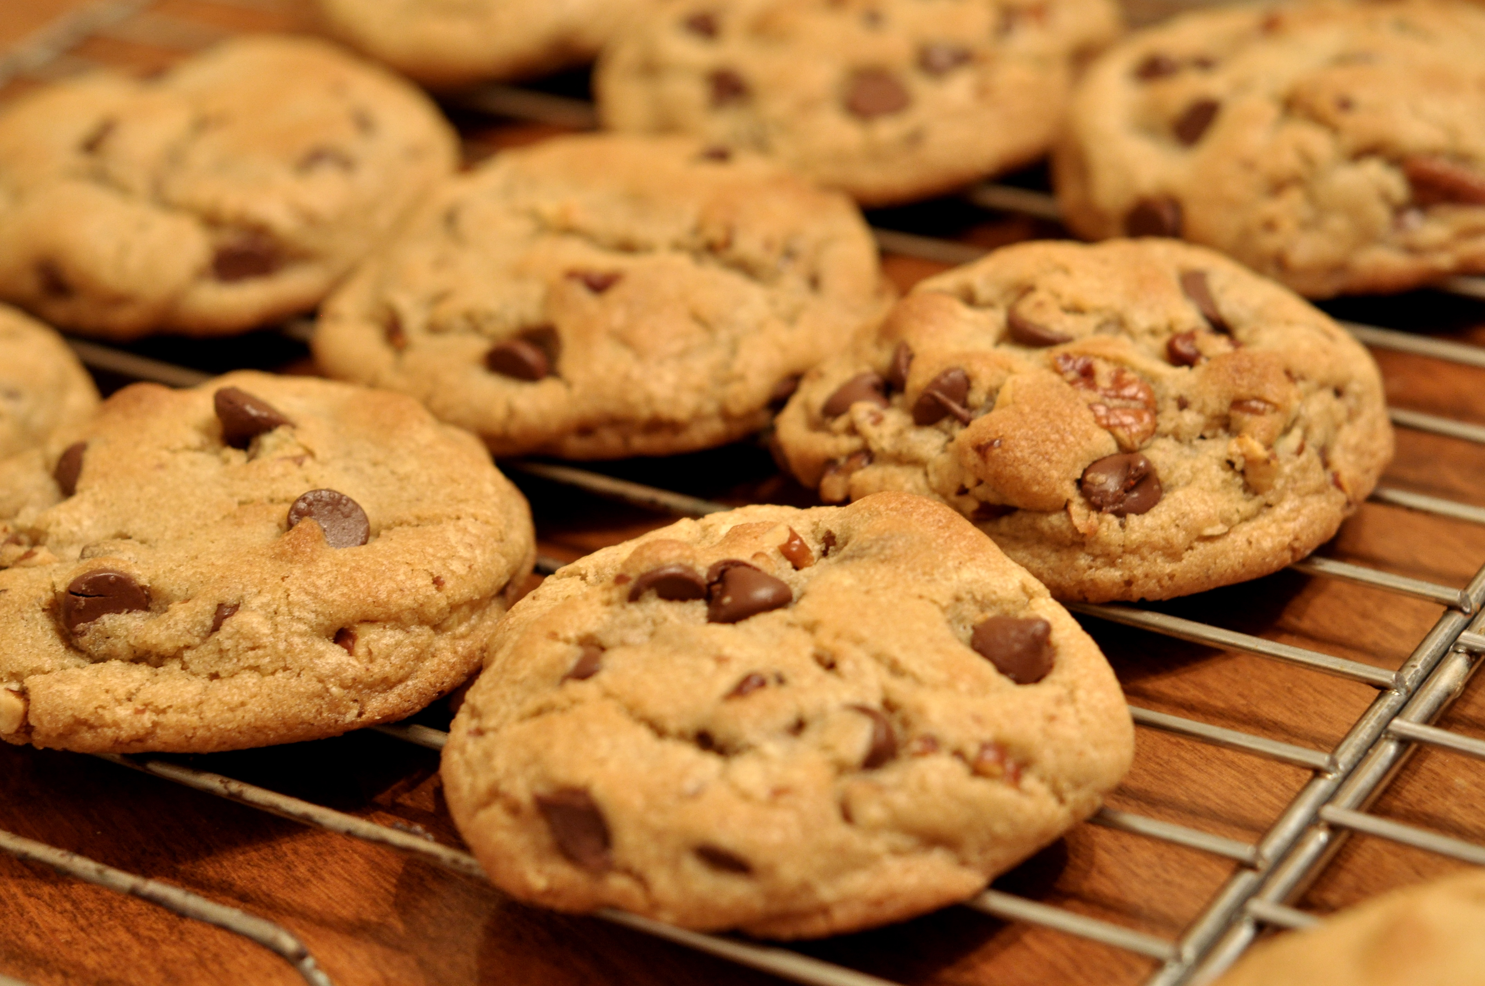](https://www.google.com/url?sa=i&rct=j&q=&esrc=s&source=images&cd=&cad=rja&uact=8&ved=0ahUKEwji-MzE7KzNAhVMb1IKHakBBj4QjRwIBw&url=https://en.wikipedia.org/wiki/Chocolate_chip_cookie&psig=AFQjCNF5R0KxkDSsvi_mn993tWtPNzWlsw&ust=1466176848239556)

[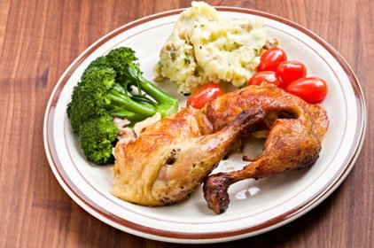](https://www.google.com/url?sa=i&rct=j&q=&esrc=s&source=images&cd=&cad=rja&uact=8&ved=0ahUKEwjH8tCc7KzNAhUVSFIKHWHlAMYQjRwIBw&url=https://www.thehunt.com/finds/E7v8Uf-dinner---google-search&psig=AFQjCNG5QodIQGdwxO7h3lvPQgliBK8V9g&ust=1466176758280110)

**Moreover I had a sleep over. made a cake for goodness sake**

[](http://www.google.com/url?sa=i&rct=j&q=&esrc=s&source=images&cd=&cad=rja&uact=8&ved=0ahUKEwiL0qjN-J3NAhVo4YMKHYbaAhsQjRwIBw&url=http://www.todaysparent.com/family/parenting/10-tips-for-successful-sleepovers/&psig=AFQjCNHnaS3AxfE5H1O5BJwTdUPjN9GPiw&ust=1465664680541288)

[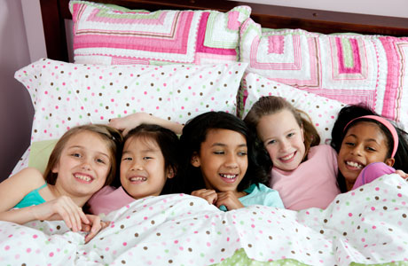](https://www.google.com/url?sa=i&rct=j&q=&esrc=s&source=images&cd=&cad=rja&uact=8&ved=0ahUKEwj-yPGS-J3NAhVB4IMKHTwKBMYQjRwIBw&url=https://www.parentmap.com/article/five-easy-questions-what-you-should-ask-before-the-sleepover&psig=AFQjCNHvn1Y_EKqwp4BvHWJXrLUAseYSmA&ust=1465664547264168)

[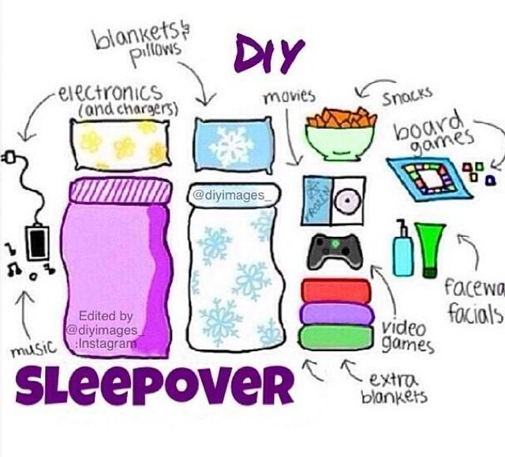](https://www.google.com/url?sa=i&rct=j&q=&esrc=s&source=images&cd=&cad=rja&uact=8&ved=0ahUKEwiG9sCe8KzNAhUUXVIKHfo_AWsQjRwIBw&url=https://www.pinterest.com/pin/435371488950902314/&bvm=bv.124272578,d.aXo&psig=AFQjCNFNtDJb1rVQJ_m9ZVSpFBUigggUWw&ust=1466177775209823)

Some adult said time for bed

But there was more to be said

There was a little wait

Then we talked until late.

**I went to a museum**

**Oh my, oh me, there was so much to see.**

**It was cool**

**At every turn**

**there was something new to learn.**

[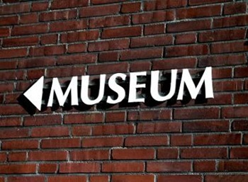](https://www.google.com/url?sa=i&rct=j&q=&esrc=s&source=images&cd=&cad=rja&uact=8&ved=0ahUKEwjo15aMiZ7NAhUDGlIKHZCAAG8QjRwIBw&url=https://www.smu.edu/News/2014/arts-research-gender-equity-07march2014&bvm=bv.124272578,d.amc&psig=AFQjCNH7sTfWcika8mY5U5_hAdqYpeBCkQ&ust=1465669113588382)

**I even took a flight in a plane.**

**I was glad there was no snow or rain.**

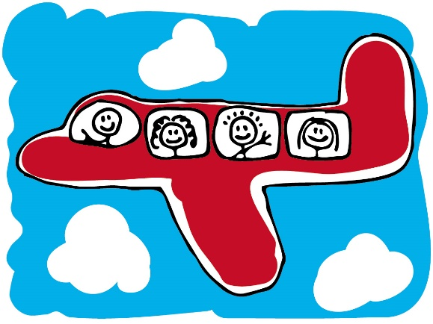

**Wait until he you hear what up next year**

***“I’ll be bigger and smarter and ready for new adventures.”***



Insert child’s photo

**‘It will be a ton of fun.”**

**Join me and see!!.**

**“Happy Adventures Amelia”**

[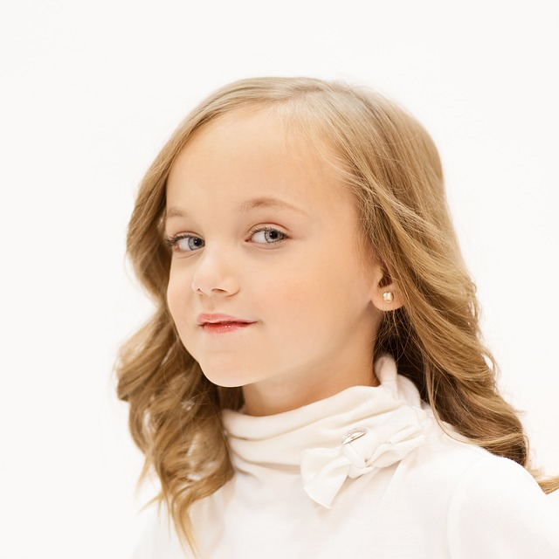](https://www.google.com/url?sa=i&rct=j&q=&esrc=s&source=images&cd=&cad=rja&uact=8&ved=0ahUKEwikj-P3wozMAhUCjz4KHdX3BpoQjRwIBw&url=https://pixabay.com/en/girl-young-blue-eyes-look-looking-545510/&psig=AFQjCNG7ynn76sexEoPYz9Od2pSPmWw2Xw&ust=1460668118494125)

Insert child’s photo